Contents of Pack:
Health and Safety Manual
Anti-Bullying Policy
Asset Register for Plant and Equipment
Banned Items Register
Basic Scaffold Check for Workers
Competency Check
Confined Space Checklist
Contractor Approval Form
Drug, Alcohol, and Substance Impairment Policy
Emergency First Aid (information on first aid kits
Emergency Plan
Emergency Response – CPR
Emergency Response Drill
Environmental Sustainability Policy
Event Report
Fall Protection for Tools Checklist
Fire Response (with information about different fire extinguishers)
Fitness for Work Policy
General Emergency Response
Ground Disturbance Standard
Hard Hat Checklist
Harness Inspection Certificate
Hazard Identification Form
Hazard Register – Option 2
Hazard Register Template
Hazardous Substances Inventory
Health and Safety Policy
Incident and Hazard Report Register
Informal Reporting of Unreasonable Behaviour
Injury Management Policy
Job-Start Form Option 2
Job-Start Form Option 1
Ladder Inspection Checklist
Lanyard Inspection Checklist
Lanyard Inspection Certificate
LPG Leak Response
Manual Handling Control Form
Mental Health and Wellbeing Policy
Monthly Toolbox Meeting Minutes
Monthly Vehicle Inspection Checklist
New Employee Induction Checklist
Permit to Work
PPE Issue Register
Restricted Items Register
Safe Work Method Statement (SWMS) Template
Safety Alert Template
Scaffold – Site Assessment
Scaffold Checklist
Scaffold Handover Certificate
Self-Report of Discomfort
Site Inspection Checklist
Spill Response (with information on spill kits)
Standard Operating Procedure Template
Training and Competency Register
When disaster strikes
Witness Statement Record
Working at Height Rescue Procedures
Working at Heights Standard
Workplace Inspection
Workstation Ergonomics Assessment
Your Emergency Response Plan Guide

Health and Safety Manual

  - Version:
  - Date:
  - Review Date:

Contents
Health and Safety Manual 5
Health and Safety Management 10
Worker Engagement and Communication 10
Hazard Identification 10
Risk Management 11
Information, Training and Supervision 12
Monitoring and Review 13
Hazardous Substances 13
Events (injury/illness/incident/near miss) 14
Event Reporting and Recording 14
Event Investigation 15
Injury Management 15
Emergency Procedures and First Aid 15
Notification of Hazardous Work 16
Safe Plant and Equipment 16
Personal Protective Equipment (PPE) 17
Health Monitoring 17
Isolate or Lone Workers 18
Potentially Harmful Work Environments 18
High Risk Work 19
Isolation of Supply – Lock Out/ Tag Out 20
Prequalification and Management of Contract Workers 20
Job Health and Safety Management 21
Site Specific Safety Plans 21
Work Preparation and Job Induction 21
Client and Visitor Induction 22
Hazard Identification and Risk Management 22
Toolbox Meetings 22
Definitions 22

Health and Safety Manual

Our Health and Safety Manual will assist us in addressing our responsibilities under the Health and Safety at Work Act 2015 and Health and Safety at Work (General Risk and Workplace Management) Regulations 2016.

The following is a summary of the main legal obligations contained in the Health and Safety at Work Act 2015 and Health and Safety at Work Regulations 2015. Definitions of relevant terms contained in the Act and Regulations are also included:

PCBU DUTIES UNDER THE ACT

Every Person Conducting a Business or Undertaking (PCBU) must comply with health and safety legislation.

Ensure the safety of workers and others

As a PCBU you are required to ensure the safety of workers and others, so far as reasonably practicable. This includes workers who are employed or engaged by you, workers who are directed or influenced by you and any other person who enters your place of work or who is put at risk by your work.

To address your duties as a PCBU you must ensure you provide and maintain (as far as reasonably practicable):
- A work environment without risks to health and safety.
- Safe plant and structures.
- Safe systems of work.
- The safe use, handling, and storage of substances.
- Adequate facilities for the welfare at work of workers.
- Any information, training, instruction, or supervision that is necessary to protect all persons from risks relating to the work they are doing.
- Monitoring the health of your workers and the conditions at the workplace to prevent illness or injury; and
- You must also maintain any premises so that a worker occupying the premises is not exposed to risk.

Duty to provide training and supervision

PCBUs are also required to provide worker training and supervision. Workers must be competent to do their work, made aware of the potential hazards and expected risk controls. There must be a system for dealing with any emergencies that occur at work.

Duty to notify events

PCBUs must notify WorkSafe NZ of any Notifiable Events, which include a death, notifiable incidents and notifiable injury or illness.

Duty to engage workers

PCBUs are required to engage with workers on health and safety matters.

Right of workers to refuse work

Workers have the right to refuse to do work that could cause them harm.

Health and Safety obligations

PCBUs cannot contract out of health and safety obligations.
Duty to ensure workplace is safe

A PCBU with management or control of a workplace must also ensure that the workplace, the means of entering and exiting the workplace, and anything arising from the workplace are without risks to the health and safety of any person.

Duty to consult with other duty holders

PCBUs who have a duty relating to the same matter (e.g., working on the same job) must, so far as is reasonably practicable, consult, co-operate with, and co-ordinate activities with all other PCBUs who have a duty in relation to the same matter.

PCBU DUTIES UNDER THE REGULATIONS

Identify hazards

PCBUs have a duty to identify foreseeable hazards that could give rise to risks to health and safety.

Review risk controls

PCBUs who implement risk controls must ensure they are effective, maintained and remain effective, including ensuring they are:
- Fit for purpose.
- Suitable for the nature and duration of the work; and
- Installed, set up and used correctly.

Duty to maintain controls

PCBUs must review and revise risk control measures to maintain a work environment that is free of risks to health and safety. Reviewing risk controls is required:
- When the control does not control the risk (e.g., after a review or accident).
- Before a change at the workplace that could create a new risk (e.g., use of new equipment or change of job step).
- A new hazard or risk is identified (by a worker or other person); and
- As a result of a health monitoring report.

Provide training and supervision

PCBUs must ensure that every worker conducting work, using plant or handling substances:
- Has the knowledge and experience to ensure the work they are doing does not cause harm to the worker or others.
- or Is supervised by a person who has the knowledge and experience; and
- Is adequately trained in the safe use of plant, objects, substances, and equipment that the worker is required to be used; and
- Has all protective clothing that the worker is or may be required to wear.

Manage airborne contaminants

PCBUs with management or control of a workplace must ensure that facilities are provided:
- To control airborne contaminants as closely as possible to their source; and
- For the treatment of or carrying off airborne contaminants to minimize the chance of harm to workers.

Provide first aid

PCBUs must ensure:
- That adequate first aid equipment is provided for the workplace and is accessible to all workers; and
- An adequate number of workers are trained to administer first aid; or
- Workers have access to an adequate number of persons who have been trained to administer first aid.

Provide an Emergency Plan

PCBUs at a workplace must ensure that an emergency plan is prepared for the workplace.
The Emergency plan must provide emergency procedures that:
- Provide an effective response to an emergency.
- Detail how to evacuate.
- Detail how to notify emergency services and others at the earliest opportunity.
- Identify medical treatment and assistance to be provided.
- Provide effective communication to coordinate the emergency response.
- Provide for regular testing of the emergency plan; and
- Provide effective communication, training, and information to workers to implement the emergency plan.

Provide PPE

PCBUs who direct the carrying out of work must provide PPE to workers unless the PPE has been provided by another PCBU.

PCBUs must ensure that the PPE selected is:
- Suitable for the nature of the work and the hazards associated with the work.
- A suitable size and fit and reasonably comfortable for the worker who uses it.
- Clean and hygienic; and
- In good working order.
- PCBUs must also ensure:
- PPE is used or worn by the worker.
- PPE is compatible with any other PPE being used or worn by the worker; and
- That workers are trained in the use and maintenance of PPE.

Manage remote or isolated workers

PCBUs must manage risks to health and safety of workers associated with remote or isolated work.
When minimising this risk, a PCBU must provide a system of work that includes effective communication with a worker.

Manage hazardous atmospheres

PCBUs with management or control of a workplace must manage risks to health and safety associated with a hazardous atmosphere at a workplace.

Manage ignition sources

PCBUs with management or control of a workplace must manage risks to health and safety associated with an ignition source in a hazardous atmosphere at a workplace.

Manage falling objects

PCBUs with management or control of a workplace must manage risks to health and safety associated with any falling object likely to injure a person at a workplace.

Manage hazardous containers

PCBUs with management or control of a workplace must ensure that where there is a hazardous container at the workplace:
- It is securely covered; or
- Enclosed by a secure fence that extends 1 metre above the floor, ground, or platform.

Duty to provide health monitoring

PCBUs must ensure that health monitoring is provided to any worker who may be exposed to a substance hazardous to their health relating to:
- An identifiable disease or health effect.
- The likelihood a disease or health affect will occur under the conditions of work; and
- The use of valid techniques to detect a disease or health effect.

PCBUs are required to inform workers of all relevant information regarding the health monitoring including how the monitoring is to be conducted and the results of any monitoring.

Officer Duties

Officers of a PCBU must:
- Acquire and keep up to date knowledge of work health and safety matters.
- Gain an understanding of the nature of your operations and the hazards and risks associated with those operations.
- Ensure that when work is carried out, appropriate resources and processes are available for use (and are used) to eliminate or minimise risks to health and safety.
- Ensure appropriate processes are in place for receiving, considering, and responding in a timely manner to information regarding incidents, hazards, and risks.
- Ensure that processes are implemented for complying with any duty or obligation of a PCBU under the Act; and
- Verify (regularly check) that processes and resources have been provided and used.

Worker Duties

Workers engaged or employed by a PCBU must:
- Take reasonable care for their own health and safety.
- Take reasonable care they do not adversely affect the health and safety of other persons.
- Comply with any reasonable instruction that is given by a PCBU; and
- Cooperate with any reasonable policy or procedure of a PCBU relating to health or safety in the workplace.

When using PPE, workers must:
- Use and wear PPE in accordance with reasonable instructions of the PCBU.
- Not intentionally damage or misuse PPE; and
- Report any unfit, damaged, or defective PPE to the PCBU.

Duty to Manage Risk

As a person under the Act, you have a duty to:
- Eliminate risks to health and safety, so far as reasonably practicable, or if not reasonably practicable; to Minimise those risks so far as is reasonably practicable.

This duty applies to PCBUs, workers and other persons with a duty under the Act. In other words, risk management is everyone’s responsibility.

The most important part of this process involves the creation and use of a system that identifies hazards and manages risks.

The management of risks requires the controlling of the risk through:
- Elimination of the risk of any hazard causing death, injury, or illness; and
- If elimination is not possible by minimising the risk of the hazard causing death injury or illness.

Minimisation controls include:
- Substituting (wholly or partly) the hazard creating the risk with something that lowers the risk.
- Isolating the hazard from any person who could be exposed to it; and/or
- Implementing engineering controls.

- If the risk remains, you must further minimise the risk by using administrative controls such as: work methods.
- procedures; checklists; and PPE.

If you must minimise the risk, then where possible multiple risk controls should be used.

Health and Safety Management

Our health and safety system contains a set of Health and Safety Objectives.

These objectives help us manage our health and safety duties, ensure we implement our health and safety system effectively and demonstrate continuous improvement in occupational health and safety.

We will use these objectives as a guide to implement our health and safety procedures and each objective will be put in place progressively.

Worker Engagement and Communication

We will establish appropriate communication and participation methods with all workers in our workplace, to ensure all information regarding safety is discussed and passed on.

As a PCBU we will engage our workers to help us:
- Identify hazards and assess risks;
- Make decisions about ways to eliminate or minimise risks;
- Make decisions about the adequacy of our health and safety facilities; and decide on appropriate worker participation practices.

This will involve:
- Sharing information on health and safety with our workers;
- Allowing our workers to express their views, raise work health and safety issues and contribute to the decision-making process;

Considering the views of workers;
- Advising workers of the outcome of any discussions and decisions; and
- Involving any Health and Safety Representative in our discussions.

We will do this by:
- Inducting all workers to our workplace;
- Ensuring all workers have attended inductions for our clients as required;
- Providing sufficient information and training specific to the health and safety risks for the work being undertaken.
- Ensuring workers have an opportunity to participate in health and safety via health and safety meetings and (where applicable) health and safety representatives.
- Holding quarterly Health and Safety Meetings with management and workers.
- Agreeing (as a group) on any required actions and documenting these in our Health and Safety Meeting Minutes;
- Making the Health and Safety meeting outcomes available to all workers; and
- Holding monthly toolbox meetings where workers can raise any issues, they feel necessary.

Hazard Identification

All Hazard identified will be recorded in our Hazard Register. The Hazard Register is a record of all significant hazards that have not been eliminated and may be present in our workplace. The Register will be regularly reviewed to ensure it remains up to date.

Our Hazard Register will be held in the workplace and used as a reference document. There might be the need for a site-specific Hazard Register if work is being carried out away from our normal work premises.

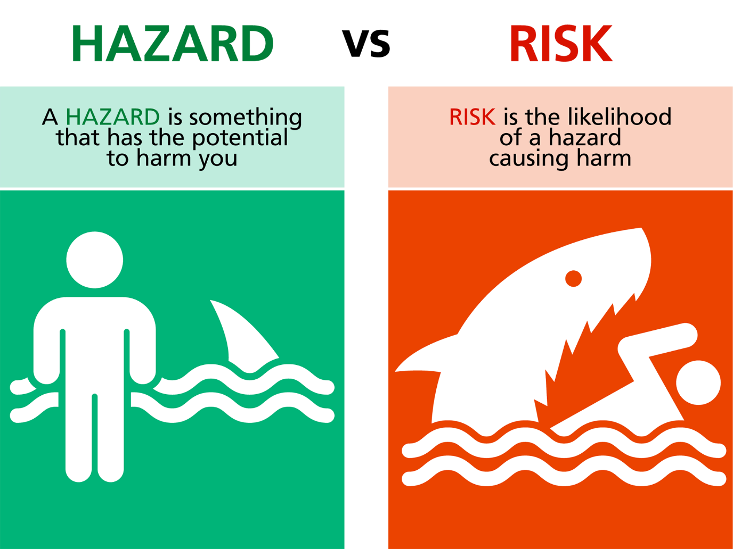

Risk Management

Once hazards have been identified they will be assessed and controlled by eliminating or minimising any risks to health and safety.

Eliminate: Where reasonably practicable, we will remove the chance of a hazard causing death, injury or illness.

Minimise: Where we cannot eliminate the risk, we will as far as reasonably practicable reduce the chance of the hazard causing death, injury or illness by one or more of the following:

- Substitute (wholly or partly) the hazard creating the risk with something that creates a lesser risk;
- Isolate the hazard from any person who could be exposed to it; and/or
- Implement engineering controls.

If the risk remains, we will further minimise the risk by using:
- Administrative controls (such as safety procedures and checklists etc); and
- Personal Protective Equipment (PPE).

Work related hazards and the risk controls are listed in the following resources:
- Hazard Register
- Safe Work Method Statement and
- Written on Workplace Hazard Board(s).

Hazards that relate to visitors entering the workplace and the actions to control risks to health and safety are written on our Hazard Board and will be displayed at the entrance(s) to the job site where required.

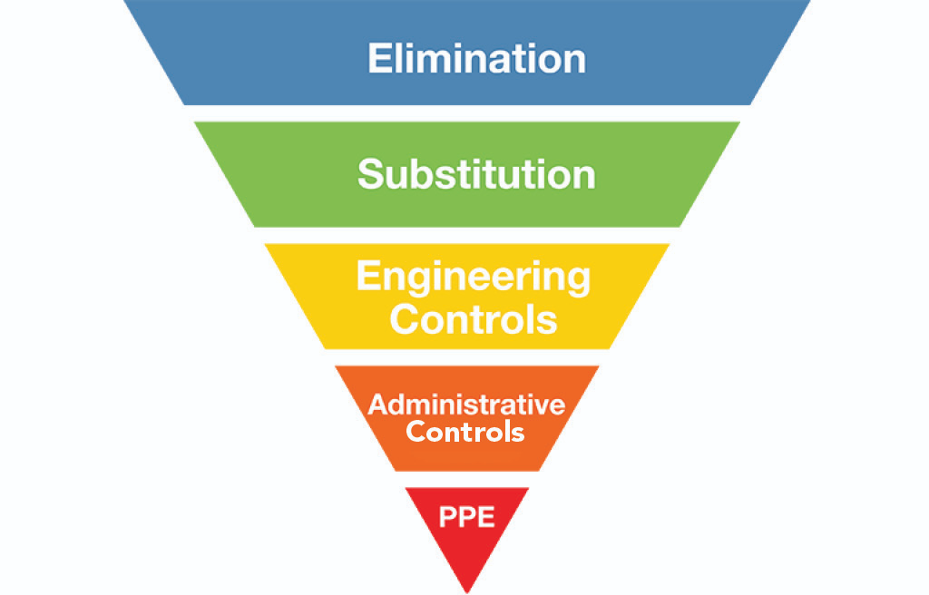

Information, Training and Supervision

We will ensure all workers are sufficiently competent and/or trained to do their work safely or are supervised by a competent person. An Initial assessment of each worker will be carried out at the stage of induction and recorded in the Training and Competency Register.

The Training and Competency Register will also be used as a tool to identify any potential training needs of our workers. Where training needs are identified those will be discussed at the Toolbox meeting and scheduled accordingly.

Any worker not competent to work alone or conduct certain task by themselves will be provided with the appropriate supervision.

We will ensure that all contractors are sufficiently competent and hold all the relevant qualifications for the work they are engaged to carry out. An assessment will be done via the Contractor Approval Form.

Workers will also be trained in the safe use of plant and equipment, including the use and maintenance of Personal Protective Equipment (PPE). Competency will be assessed via the Competency Check and updated on the Training Register.

Monitoring and Review

We will ensure all workers are meeting the required standards of health and safety by conducting regular Office Inspections or Site Inspections and others as required.

Inspection findings will be discussed with all workers at our regular Toolbox Meetings held at the workplace.

Completed Job-Start Forms, Vehicle Checklists etc. will be submitted to the PCBU. The requirement will be communicated to the worker during the workplace induction.

Hazardous Substances

Hazardous substances are substances that are explosive, flammable, oxidising, toxic, corrosive, or toxic to the environment (ecotoxic).

The HSNO classes are:
- Class 1 – explosives
- Class 2 – flammable gases
- Class 3 – flammable liquids
- Class 4 – flammable solids
- Class 5 – oxidising substances
- Class 6 – substances toxic to people
- Class 8 – corrosive substances
- Class 9 – substances toxic to the environment.

To keep our workers safe, we will put the following controls in place for hazardous substances in any quantity:
- We will keep an inventory of all Hazardous Substances used, handled, manufactured, and stored by our PCBU and our workers
- We will make the up-to-date Safety Data Sheets for all products available in our workplace and to our workers; that includes having them in vehicles where required
- We will share the relevant information, instructions and training to our workers and record their training and or competency in our training register. Where required supervision will be provided
- We will have the relevant emergency response plan in place
- We will ensure all containers are labelled as required, including hazardous waste
- We will provide our workers with additional PPE where required for safe handling of hazardous substances

Events (injury/illness/incident/near miss)

In the event of an accident where a person appears to be injured, our priority is to preserve life by providing first aid and calling the emergency services on 111.

Emergency Response Plans are available, and workers will be shown where those are available as well as the locations of First Aid Kits as part of their Induction to the workplace.

We will always aim to have a person qualified in first aid in our workplaces. Sufficient First Aid Kits will be available in the workplace and checked as part of the office check.

A First Aid Kit will be provided for each vehicle and the contents checked as part of the monthly vehicle check.

We will ensure that if there is a notifiable injury or event, our workers will preserve the accident site by leaving everything as it is until we have permission from WorkSafe NZ to clean up or
move anything. We will also take photos of the accident site as a record of what has happened.

All accidents and near miss incidents will be recorded and investigated using the Event Report Form and updated in the Incident Register.

Event Reporting and Recording

The Event Report Form for recording and reporting any incident or injury will be available in the workplace and on site. Workers are expected to report all injuries and near-miss incidents to the relevant parties as soon as reasonably practicable. The requirement will be discussed as part of the induction and at toolbox meetings if required.

Minor injuries and near miss incidents will be recorded on the Event Register by the director or worker in control of the workplace and discussed at the next Toolbox Meeting.

All notifiable events will be immediately reported to WorkSafe NZ via the online form on the WorkSafe website.

If the incident has happened on our client’s site, we will inform our client and make an incident investigation report available as early as possible.

All event documentation will be kept for a minimum of 5 years.

Event Investigation

We will investigate all accidents, incidents and near misses (events) to determine whether they were caused by hazards or risks to health and safety.

Where applicable, we will also find out what risk controls were absent and should be put in place to manage any hazard and prevent a repeat of the same occurrence.

Where required we will report back to WorkSafe NZ on the prescribed form, any system changes we have made because of an event.

All persons present at the time of the event are expected to assist in any investigation.

The worker in control of the workplace is responsible for investigating events and documenting their findings using the Event Form.

Event investigation findings will be discussed at our Toolbox Meetings and Health and Safety Meetings and a remedial action plan will be put in place, recorded in the Health and Safety Meeting Checklist, and reviewed at subsequent meetings.

Injury Management

Where harm has occurred, a managed return to work is our preferred choice depending on the degree of injury and the availability of suitable tasks that will not exacerbate the injury. We believe this outcome to be both desirable and beneficial to all parties involved.

If a Worker sustains an injury that a medical professional believes will not preclude the Worker from some form of work, our policy is (where possible) to provide useful alternative duties to ensure a continued connection with the workplace and a managed recovery. Consult with the Worker, ACC, and appropriate medical professionals to action the programme.

If an injured Worker cannot return to alternative duties, the Company will remain in contact with the Worker to monitor their progress and ability to return to work.

If a Worker has sustained a long-term injury and is not able to return to the duties they were originally employed to do, the Company will, if possible, provide alternative work that the injured Worker can do. All parties involved should be aware that this may not be feasible and that termination of employment, while never desirable, may be necessary. In this situation, the Company will do whatever it reasonably can to ease the transition.

Emergency Procedures and First Aid

We will provide a completed Emergency Plan for our workplace(s) and ensure it is available for our workers (and contractors) wherever they are doing work.

Where work is being carried out at our own premises, we will make sure the Emergency Plan is discussed as part of the Induction and location of First Aid facilities and another Emergency Equipment is discussed as well.

We will also ensure that adequate number of workers are trained as first aiders. Those qualifications are part of the Training Register and we will ensure to assess the need for additional workers requiring training on a regular basis.

Where we are required to complete a SSSP or similar for work carried out at our clients premises we will attach the Emergency Plan to the Site-Specific Safety Plan.

The supervisor or person in control of the workplace is responsible for ensuring that the Emergency Plan is kept up to date and that all workers (including contract workers) have read this and are familiar with its content.

Notification of Hazardous Work

The requirement to notify WorkSafe NZ is defined in the Health & Safety Regulations (Health and Safety in Employment Regulations 1995).

Where hazardous work is to be carried out by our company, WorkSafe NZ will be informed via the online form at least 24 hours prior to commencement of such work. Notification is completed online, via WorkSafe NZ’s website at: https://worksafe.govt.nz/notifications/hazardous-work/

An electronic confirmation will be received, and a copy of this notification will be kept for our records. A copy of this confirmation will also be added to our Site-Specific Safety Plan (when applicable).

A copy of any completed Notification of Hazardous Work Forms will be held in the workplace for the duration of the job.

If engaged in hazardous work, all workers involved will be competent to perform the work and, where applicable, will be holders of an appropriate qualification. Those records will be kept and updated accordingly in the Training Register.

Safe Plant and Equipment

We will ensure that all plant and equipment supplied to and used by workers is of the required standard and is in good working order with all safety mechanisms and guards intact.

All plant and equipment will have a Standard Operating Procedure (SOP) or manufacturers’ instructions containing information on its safe operation and maintenance.

If any plant or equipment is not in safe working order, it will be removed from service and repaired by a competent person before any further use. All plant and equipment will be recorded in the Plant and Equipment Register.

Workers will be made aware of their obligation (during induction) to regularly inspect plant and equipment and to immediately stop work and report to their PCBU, if any damage or fault poses a risk of death, injury, or illness.

There will be a requirement for workers to complete regular checks on certain plant and equipment using the relevant checklist. For example, monthly vehicle and ladder checks. The worker will be told which ones need to be completed and at which frequency during their induction.

All workers must be trained and competent to use plant and equipment before allowed using it unsupervised. The initial assessment will be recorded in the Training Register at the time of induction and any training needs identified and scheduled accordingly. Where required we will ensure that workers are supervised when using plant and equipment

Personal Protective Equipment (PPE)

Where there is a need to further minimise a risk to health and safety, we will ensure our workers are provided with the necessary Personal Protective Equipment (PPE).

We will ensure the PPE provided to our workers is:
- Suitable, considering the nature of the work and any hazards relating to that work;
- A suitable size and fit and reasonably comfortable for our workers;
- Compatible with other PPE.
- Maintained, stored, and repaired so that it continues to be effective (e.g., clean, hygienic and in good working order).
- Used or worn by workers; and
- Provided along with information, training, supervision and instruction on the proper use, storage and maintenance of the PPE.

We will establish a minimum PPE requirement for our workplace, which will be monitored during workplace inspections or day to day observations.

Specific PPE requirements for machinery, tasks and the handling of substances are identified in Standard Operating Procedures (SOPs), manufacturers’ instructions, Safety Data Sheets (SDSs) and the Hazard Register.

Where applicable, PPE such as dust masks, hearing protection etc will be maintained to a schedule and recorded in the PPE Register and relevant training in the Training Register.

We will ensure that contract workers (other PCBUs), supply suitable PPE appropriate for the job they are undertaking and make sure it is used and maintained correctly.

Health Monitoring

Where there is the risk of a specific illness through exposure to hazards and these cannot be eliminated, we will minimise these risks by monitoring the health of our workers.

Illnesses would include noise induced hearing loss, respiratory issues from exposure to hazardous atmospheres or airborne contaminants and other long-term illnesses such as asbestosis and silica dust related cancers developed in the workplace.

Where applicable we would obtain a baseline of our workers’ health by conducting pre- employment health checks and by regular on-going monitoring of workers and the workplace. This may involve obtaining specialist health monitoring advice.

We will, so far as reasonably practicable, obtain our workers consent to the monitoring of their health in relation to these hazards. We will be proactive in seeking approval and take responsibility for informing and encouraging workers about health monitoring, where appropriate.

We acknowledge consent must be granted voluntarily and without any form of coercion or duress.

We will also inform workers of the results of any health and safety monitoring undertaken to meet the risk management requirements of the Act.

Isolate or Lone Workers

When workers are working alone, or in isolated areas, where they can’t physically see or talk to other workers, we ensure the following risk controls are in place.
- Have an Emergency Plan that includes a method of regular communication.
- Worker is to be first aid trained and have a first aid kit available.
- Worker is to be fully trained and competent in the task being completed (not an apprentice or inexperienced worker).
- Workers must be provided with the correct tools and PPE
- Lone or isolated workers must be regularly checked on.

Potentially Harmful Work Environments

Where there is a risk of illness or injury through exposure to hazards and these cannot be eliminated, we will minimise these risks by monitoring exposure levels and providing the appropriate PPE.

Noise

Where noise presents a hazard in the workplace, we will ensure work is carried out in accordance with the Approved Code of Practice for the Management of Noise in the Workplace.
Regardless of whether hearing protection is being worn, we will ensure that no worker is exposed to noise above the following levels:

Eight-hour equivalent continuous A-weighted sound pressure level of 85dB; and Peak sound pressure level of 140dB.

All staff will be issued with AS/NZ 1270:2002 Class 5 hearing protection for any work that exceeds noise levels of 85 decibels. Staff will get the option between ear muffs and ear plugs of a Class 5 level.

Where appropriate we will undergo health monitoring of workers exposed to continuous or peak noise levels.

Dust, Airborne Particles and Hazardous Atmospheres

Where exposure to dust, airborne particles or hazardous atmospheres presents a hazard in the workplace, we will ensure the workplace is monitored in accordance with Regulations and WorkSafe NZ’s fact sheet, which outlines the following steps to be taken:

- Hazards must be identified;
- Risk control methods are developed and used;
- Respiratory protection is provided;
- Air monitoring of the workplace is undertaken regularly;
- Workers are trained on the hazards associated with the work they are undertaking;
- Workers are trained on the correct use and maintenance of PPE provided; and
- Warning signs are put in place as required.

Where appropriate we will undergo health monitoring of workers exposed to dust, airborne particles or hazardous atmospheres.

Loose Materials

As required by workplace Regulations, where a worker could become entrapped or engulfed by materials e.g. excavations etc, we will provide a suitable and fit for purpose safety harness attached to a securely fastened lifeline.

We will also ensure a suitably trained and competent worker is stationed to immediately rescue any worker who becomes trapped or engulfed.

High Risk Work

As a PCBU we will ensure that all high-risk work is carried out in accordance with the relevant standards, codes of practice and guidelines.

Electrical Work

A qualified and registered electrician, with a current practicing license, must carry out all prescribed electrical work as outlined in AS/NZS 3000:2007 Electrical Installations. All electrical work carried out must have a certificate of compliance provided by the electrician upon completion.

Gas Installations

A qualified and registered gas fitter, with a current practicing license, must carry out all installation work as outlined in AS/NZS 5601:2013 Gas Installations. All installation work carried out must have a certificate of compliance provided by the gas fitter upon completion.

Working at Height

All work at height will be carried out in accordance with the best practice guidelines for Working at Height in New Zealand. All workers using harnesses at height will be trained in the safe use of a harness for fall protection when working at height Unit Standard (US) 23229 and all supervisors will be trained to US 15757.

If a Mobile Elevating Work Platform (MEWP) is required, then all work will be carried out in accordance with the best practice guidelines for mobile elevating work platforms. Any worker required to operate a MEWP will be trained to the relevant US for the type of MEWP as outlined in the guidelines.

Confined Spaces

All work carried out in a confined space as defined by AS/NZS 2865:2001 Safe Working in a Confined Space, must be carried out in accordance with the standard. All workers undertaking work in a confined space will be trained to US 17599 & US 18426.

Asbestos

All work involving the identification, removal, handling, disposal of asbestos containing material (ACM) or asbestos contaminated dust (ACD) will be conducted in accordance with Health and Safety at Work (Asbestos) Regulations 2016 and the Management and Removal of Asbestos Approved Code of Practice (ACOP).

Where our work creates a risk of asbestos contamination, asbestos has been identified or it is assumed asbestos is on site, we will ensure that we obtain and review an Asbestos Management Plan from the building owner or the person who has management or control of the site.

Where required to remove and dispose of asbestos a licensed asbestos removalist (Class A or B) will be used. If a licensed removalist is not required (up to and including 10m2 of non-friable ACM or ACD, cumulatively over the whole course of the removal project for the site), we will ensure the removal process is in accordance with the Asbestos Regulations and Management.

Isolation of Supply – Lock Out/ Tag Out

All work that effects or interferes with the supply or potential supply of gas, electricity or water shall be carried out under a Lock Out/Tag Out system.

This system shall consist of a physical lock being placed at the point of isolation with an identification tag with the name and number of the qualified person completing the isolation.
If more than one worker is reliant on this isolation, then he/she will place his/her own lock and identification tag at the isolation point. This is to ensure that no point of supply can be re-instated without the knowledge of all affected by the isolation.

Lock Out/Tag Out systems must not be removed or reinstated by any person other than the person who installed them.

All other mechanically generated sources of energy, such as pneumatic or hydraulic energy sources, should also be physically isolated (e.g. chocked or secured with a chain etc) when undergoing maintenance and/or servicing.

Prequalification and Management of Contract Workers

As a PCBU we will ensure all workers, including any contract workers, have and use the appropriate resources and processes to eliminate or minimise health and safety risks.

To do this we will pre-qualify new contract workers, to ensure they are competent in health and safety management via the Approval Form. No contractor can start any work without having gained formal approval form us.

If any of our work involves the engagement of or working alongside other PCBUs (e.g., sub-contractors working on the same job), we will consult and cooperate with all contractors involved and coordinate all activities to ensure risks are managed appropriately.

Job Health and Safety Management

To manage the overall safety for each job, prior to the start of any work, we will follow the procedures outlined in the Health and Safety Manual.

The worker in control of the workplace will be responsible for carrying out these procedures. And not to start any work without ensuring hazards have been identified and controlled.
Where required we will train our staff in the use of SOP, SDS, Hazard ID Form and SWMS etc.

Site Specific Safety Plans

Where required by our clients we will submit a Site-Specific Safety Plan (SSSP) prior to the start of the project.

Work Preparation and Job Induction

Prior to the start of any work, all workers are expected to ensure they carry out a Job-Start Form.

That step ensures workers are suitably prepared for the work they are about to do.
If more than one worker is present the supervisor or worker in control will induct all workers to the workplace.

Where applicable workers will also be taken through the SWMS or SSSP for the work being carried out. Once that is done workers need to sign onto the relevant document confirming their understand and agree with the process outline in the documents.

Where working with other workers on the same site there might be the requirement to discuss the hazards and controls in the Job-Start Form with other workers to ensure everyone is sufficiently aware of Hazards and relevant controls.

Where necessary the Hazard Board should be updated with new Hazards introduced to the workplace.

Client and Visitor Induction

When applicable, the Client will be informed of any hazards that they might encounter while we are doing work.

Visitors to the workplace should be met at the entrance to the workplace and taken through the Visitor Induction, then escorted for the duration of their visit.

Hazard Identification and Risk Management

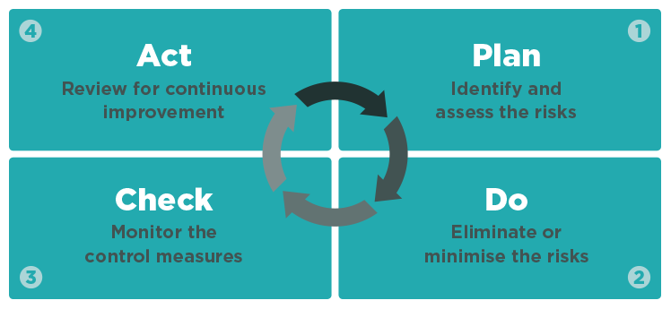

Toolbox Meetings

We will carry out monthly toolbox meetings which are mandatory to attend for all workers and will be recorded in the Toolbox Meeting Minutes.

Definitions

Reasonably Practicable: means what can reasonably be done to ensure health and safety considering:
- The likelihood of the hazard occurring;
- The degree of harm that might occur;
- What the person knows or should know about the hazard and how to manage it;
- The availability of ways to manage the hazard; and
- The costs versus the risk

Workplace: a place where work is carried out including where a worker goes while at work (includes vehicles, mobile structures, aircraft, ship etc).

PCBU: a person conducting a business or undertaking, whether alone or with others and regardless of for profit or gain – excludes those defined as workers.

Officer: a company, any person occupying the position of director, a partnership, any general partner, body
corporate, an unincorporated body and any person occupying a position in such an organisation. Any person who makes decisions in an organisation that affects the whole or substantial part of the business.

Worker: a person who carries out work in any capacity for a PCBU (includes employees, contractors,
subcontractors, employees of labour hire companies, apprentice or trainee, person gaining work experience and volunteers)

Risk: the possibility that death, injury or illness might occur when a person is exposed to a hazard.

Hazard: a situation or thing that has the potential to cause death, injury or illness (includes a person’s behaviour).

Health: means physical and mental health.

Risk Management: controlling a hazard through Elimination or Minimisation strategies or controls.

Visitors: includes groups such as customers, hospital patients, contractors or other visitors to a workplace, an employee’s family, passers-by and any other person who may be affected by the work activity.

Plant: any machinery, vehicle, equipment (including PPE), appliance, container, implement, or tool and any component or fitting connected to any of these things.

Notifiable Event: means the death of a person or a notifiable injury or incident (refer www.legislation.govt.nz for full definition).

Training: the provision of adequate (relevant to the nature of the work and its risks) and readily understandable information or instruction.

- Best practice guideline for working at height
- Best practice guideline for working on roofs
- Best practice guideline for scaffolding in NZ
- Industrial rope access in NZ
- Manual handling code of practice
- Mobile elevated work platforms
- Safe use of portable mechanically powered nailers and staplers
- Respiratory protection
- Safe use of safety nets
- Guide for safety with underground services

These documents and related fact sheets can be viewed on WorkSafe NZ’s web site at the following link: https://worksafe.govt.nz/

Anti-Bullying Policy

Bullying at work has the potential for:
- serious consequences
- an individual to experience health problems, loss of self-esteem and performance ability
- divisions in the workplace to occur as people take sides
- financial and productivity losses for workers and the company.

Bullying is defined as unreasonable and repeated behavior towards a person or group that can lead to physical or psychological harm.
Repeated behavior is persistent and can include a range of actions.
Unreasonable behavior covers actions which a reasonable person wouldn’t do in similar circumstances, including victimizing, humiliating, intimidating, or threatening a person.
A single incident isn’t considered bullying but can escalate if ignored. Managing performance in line with business policies and processes is not bullying.

Company X will do the following to minimise and respond to workplace bullying.
Senior management and the board of directors will minimise workplace bullying by:
- establishing respect for the broad range of human values and character strengths required for this organisation to survive
- actively looking for ways to create a positive workplace (‘healthy work’) that workers feel is pleasant, fair, rewarding and positively challenging
- encouraging positive leadership styles and investing in our managers to achieve this
- training key workers to receive bullying reports and give support and advice
- directing attention towards behaviour rather than people, and aiming to promote harmonious relationships across the organization
- providing workers who believe they’ve been bullied with a range of options to resolve the issue
- promoting low-key solutions before formal actions where appropriate
- aiming to repair the working relationship and promote positive work values
- openly discussing bullying, in both formal and informal settings, and providing information and training about it
- identifying factors that contribute to bullying, and putting effective control measures in place
- ensuring our processes and systems are fit for purpose and regularly reviewed
- having regular worker surveys on our work culture.

Workers agree to:
- tell their managers if they experience or see any bullying behaviours – if the manager is the person behaving in a bullying manner then advise (name other contacts)
- try low-key solutions (e.g. talking to the person initially (if safe to do so))
- follow the company’s informal or formal processes when making a complaint
- keep an eye out for other people, providing support when seeing a person being isolated or experiencing reprisals
- accept that perceptions of bullying may need to be negotiated.
Managers agree to:
- ensure workers have clarity on what their roles entail
- intervene early to call out and deal with any unreasonable behaviour before it escalates
- record and investigate complaints fairly and in line with the business or undertaking's policies and processes
- look for informal solutions before escalating an issue to higher levels (e.g., mediation or investigation) where appropriate.

When dealing with an allegation of bullying our company will:
- treat all matters seriously and investigate promptly and impartially
- ensure neither the person who complained nor the alleged bully are victimized
- support all parties involved
- find appropriate remedies and consequences for confirmed bullying as well as false reports
- communicate the process and its outcome
- ensure confidentiality
- use the principles of natural justice
- keep good documentation
- have specialist external advisors available to help.

This policy was developed by add relevant people (e.g., representatives from the board of directors, senior management, line managers, workers, HSRs/HSCs and unions)

Signed by Director or Officer of the Company
Date
Review Date

Asset Register for Plant and Equipment

Asset Reference Number | Asset Name (Model) | Asset description (where required) | Serial Number | Purchase Date | Checks Required?  Frequency?
1
2
3
4
5
6
7

8

Banned Items Register
This Register specifies plant, equipment and miscellaneous items identified as posing an unacceptable hazard. The intent of this Register is to ensure awareness of items that are not to be brought on to or used on our sites under any circumstances.

Reference Image | Banned Item | Justification | Alternatives for Consideration

Basic Scaffold Check for Workers

Site Address
Date
Full Name of worker conducting the check
Signature

 | Yes | No
Is there an Unsafe Tag or Safe Tag by the entry point?

Has the scaffold been inspected within the last 7 days (after any alteration or adverse weather event)?
Does the ladder extend 1m past the entry point?

Is there a self-closing gate by the entry point?

Is the scaffold fully decked out?

Are there toeboards installed all around to prevent objects from falling?
Is there a Top and Mid Rail?

Is there an internal handrail for any scaffold more than 300mm away from the work surface?
Is there a need to secure the ladder from unauthorised entry while the scaffold is not in use?

Remember NOT to alter scaffolding! If it is not suitable for the task – get in touch with the scaffolder and have them alter the scaffold.

Competency Check

Assessment to check if worker is competent in using a ladder

Ask the worker to show you how to check a ladder
Sticker |  | Wight Rating |  | Condition

Ask the worker to show you how to set up the ladder
Stable ground |  | Stays

Ask the worker to show you how they would use the ladder and complete the task
3 points of contact |  | No overstepping |  | No overreaching

Check completed by:
Full Name of Worker
Position
Signature
Date

Full Name of Assessor
Position
Signature
Date

Confined Space Checklist
This Checklist complements the Permit to Work for Confined Space Entry

Identify Confined Space
Determine whether the space to be entered is a confined space
Get a copy of methodologies or safe work practices documentation (e.g., SWMS)
Get all the required equipment for safe entry and emergency evacuation
Visually inspect all the equipment is in good condition, working properly, and calibrated/ certified within the period
Verify all the entry teams hold current competency for confined space entry
Check the weather forecast is favorable (if necessary)

Before Entering the Confined Space
Discuss the planned work with Permit Issuer to ensure no conflict with recent or adjacent work
Obtain any additional permits that may be required, e.g., isolation, or hot work
Assemble the equipment required for the safe performance of the job
Erect barriers around the work area and any manholes that are to be fitted
Identify, and implement measures to control any hazards likely to affect workers (refer to SWMS)
Establish evacuation and rescue procedures and review them with team
Discuss with the team what work is to be done, how, and by whom
Check communications, for example, contact base on radio/ cell phone, to establish contact can be made in an emergency
Verify all hazards are controlled (e.g., energy and material sources isolated or de-energised)
Confirm there are enough workers to carry out the planned work safely
Confirm the entry team have all the required equipment to do the job safely
Check that the entry team has the correct protective clothing and equipment
Again, check all the equipment is in good condition and working properly
Discuss health and safety issues and emergency and evacuation procedures and hazards
Check all rescue equipment is erected and in place
Check that the confined space is adequately ventilated
Test and determine the air in the confined space to ensure that it is within limits
Determine that entering the space should not affect the team’s health or safety
Implement a system to record entry to, and exit from, the confined space and appoint Stand-by persons
Review all controls with Permit Issuer and receive the Confined Space Entry permit
Give the final permission for the team to enter the confined space

During Confined Space Work
Follow all designated safe working practices (refer to SWMS and Confined Space Entry permit)
The entry team wears all required personal protective clothing and equipment
Maintain contact between the Entry Team can communicate with the Stand-by Person(s)
Test the emergency evacuation procedures if relevant (i.e., depending on how site-specific the plan is, and whether the procedures have been previously tested for the type of confined space)
Investigate/ evacuate if an alarm sounds on the gas monitor (immediate evacuation required for high alarms), if ventilation fails, or following any event which potentially affects the safety of those in the space
Evacuate if any worker begins to be affected by the atmosphere

Once Work is Completed
Check all equipment, materials, and personnel are safely removed from the space
Check all entrances to the confined space are properly closed and secured and signage is in place
Check the whole work site to a safe condition
Remove all temporary barriers erected around work areas
Complete and return the Confined Space Entry Permit to close out with the Permit Issuer

Contractor Approval Form

Company Name
Address
Trade Activity
Number of Employees
Main Contact (Full Name)
Position
E-mail
Contact Number

Health and Safety
H&S Contact (Full Name) |  | Contact Number
Position |  | E-mail

Does your company hold an external Pre-Qualification? | Yes |  | No
If yes, please specify:

Health and Safety Questions | Yes | No
Are all workers trained and competent for the work/ task they undertake?
Do you have a system to identify and control risks and hazards?
Do you carry out and record regular Health and Safety inspections?
If yes, please specify:

Do you have a system for reporting and recording incidents?
Do you investigate incidents?
Are corrective actions and learnings communicated back to workers?
Do you monitor the effectiveness of corrective actions?
Do you have a system to ensure plant and equipment is fit for purpose and safe to use?
Do you have a system to identify and record workers’ training and competency?
Do you have an emergency response plan for work undertaken for us?

Environmental
Does your company have an Environmental Management System? | Yes |  | No
If yes, please specify:

Quality
Does your company have a Quality Management System? | Yes |  | No
If yes, please specify:

References
Please provide contact details for three people who can provide references to verify capability, competency, and health and safety practices:
Full Name | Company | Contact Number

Insurances
Please provide a copy of the following certificates with this application:
 | Contract Works |  | Public Liability |  | Professional Indemnity
 | Motor Vehicle |  | Construction Machinery |  | Other (state)

Supporting Documents
Please provide a copy of the following documents with this application:
 | Health and Safety Manual |  | Environmental Manual |  | Quality Manual
 | Drug and Alcohol Policy |  | Hazard Register |  | Induction Information
 | Training/ competency register |  | Plant/ Equipment Register |  | Incident Register
 | Sample SWMS (or similar) for work completed within the last 3 months

While working on any of our sites any person employed or engaged by our Company agrees to:
- Comply with all occupational health and safety laws, statutes, regulations, codes of practice, and industry best practice guidelines applicable to the works.
- Prior to commencing work on site, all personnel are required to attend a Health and Safety induction and then a refresher induction will be completed on an annual basis.
- Attend any meetings with site staff as requested to discuss all health & safety, environmental and quality aspects related to the work on site. These may include but are not limited to, daily pre-start meetings and weekly toolbox meetings. The meeting schedule will be advised.
- Provide copies of any health and safety audits (including internal, external, and WorkSafe NZ inspections) to us.
- Prior to commencing any works, the Contractor, Subcontractor, or PCBU is required to submit a site-specific safety management plan, where applicable.
- Take all reasonably practicable steps and positive action to identify and control health and safety risks and hazards and environmental risks in the work area.
- Organise activities so that no harm comes to any personnel and so that no damage is done to property or the receiving environment
- Report immediately any incidents that occurred on one of our sites.
- Ensure that all its employees or any other personnel engaged to conduct activities are trained, competent, and experienced for the work that they are undertaking and, in the health, and safety requirements applicable to the works.
- Provide copies of all notifications to Work Safe NZ to us.
- Maintain and operate plant and equipment in a safe condition and manner and ensure all plant and equipment is appropriately tested or certified at the time of use.
- Comply with the Personal Protective Equipment (PPE) on site, provide personnel with all PPE and PPC required for safely carrying out the work, and ensure it is always used correctly.

Full Name |  | Signature
Position |  | Date

Internal use
Application approved | Yes |  | No
Approved by
Position

Signature
Date

Drug, Alcohol and Substance Impairment Policy

Purpose
The purpose of this policy is to:
- Show our responsibility and commitment to ensure a safe and healthy workplace for all workers.
- Ensure that the workers at XYZ (referred as the ‘Company’) can work in an environment free of alcohol and drug use or abuse.
- Outline the Company’s expectations and requirements for creating and maintaining an alcohol and drug-free work environment, and for dealing with substance abuse in the workplace.
- Provide an opportunity to workers members with a substance use problem to get well rather than provide grounds to terminate the employment.
Scope
This policy applies at the workplace, to all workers and members of the company. All individuals working at Profile Scaffolding are expected to report fit for duty for scheduled work and be able to perform assigned duties safely and acceptably without any limitations due to the use or after-effects of alcohol, illicit drugs, non-prescription drugs, or prescribed medications or any other substance.
- Off the job and on the job involvement with alcohol or drugs can have adverse effects on the workplace, the integrity of our work product, the safety of other workers, the well-being of our workers’ families, and the ability to accomplish the goal of an alcohol and drug-free work environment. The Company, therefore, emphasises that it has zero tolerance for workers who arrive at work under the influence of alcohol or drugs, whose ability to work may be impaired in any way by the consumption of alcohol or drugs, or who consume alcohol or drugs on Company property.
- The Company strictly prohibits the use, making, sale, purchase, transfer, distribution, consumption, or possession of prohibited drugs or alcohol on company property. The Company reserves the right to conduct searches for drugs or alcohol, including, but not limited to, searches of lockers, filing cabinets, desks, packages, etc, which are on Company property or in a Company facility. Any drugs or alcohol found because of such a search will be confiscated and the occupant or user of the object searched will be subject to disciplinary action, up to and including termination of employment or engagement.
- The Company reserves the right to undertake random drug and alcohol testing for any position within the company.
- Selection of key role workers will include management and owners or directors of the company who are involved in key roles. Testing of owners or directors of the Company will be undertaken by a third-party tester to maintain transparency for the Company.
Responsibilities of Workers
It is the responsibility of all workers to identify concerns about any individual’s immediate ability to perform their job and take appropriate steps. Where necessary, they will advise a senior person who will act such as stopping the workers member who is suspected of breaching this policy from performing his or her work, pending testing and a decision on the result including potential disciplinary action.
- If a worker or other person arrives at the workplace, (on Company property) and there is reasonable cause to suspect that they are under the influence of alcohol or drugs, they will be stood down from the work environment.
- Unexpected circumstances can arise when an off-duty worker member is requested to work. It is the workers’, member’s responsibility to refuse the request and ask that the request be directed to another person if the member feels unfit due to the influence of alcohol or other drugs.
- Workers who have been prescribed medication are expected to ask their doctor if the medication will have any potential negative effect on job performance. They are required to report any potential risk, limitation or restriction for whatever reason that may require modification of duties or temporary reassignment and provide appropriate medical verification on any restrictions in the performance of their duties.
- If a worker or contractor believes a person in a more senior position is in violation of this policy, they are encouraged to get a second opinion where possible. They are also expected to notify others such as their team leader, manager or someone in a role who can take appropriate action.
- In support of any person who may have developed or is developing an addiction to a chemical substance, all employees and contractors are required to report any violation of this policy. Any worker, co-worker, contractor, or supervisor not doing so is enabling the dependence. Enabling behavior leads to ongoing health and safety concerns for an affected individual and those around him or her.
Drug and Alcohol Testing Procedures
All testing will be performed using a non-intrusive drug test (a urine test at times post-incident maybe a blood test if urine is not possible) and an alcohol breath test which may be conducted by a registered medical professional.
- Pre-employment
Any person who has applied to be employed or engaged in a key safety role will be tested prior to beginning that role.
- Random testing
Selection of key role workers for random testing will be conducted in a clear, transparent manner and in accordance with “good faith”. A random number generator will be used for selecting persons to be tested.
- After accidents or incidents
Any workers employed or engaged in a key safety role who are involved in any accident or incident where serious harm did or may have resulted will, prior to continuing that role, be required to undergo an immediate test.
- With reasonable cause during working hours
Where there are reasonable grounds for suspecting that a worker is impaired while at work, the workers member will be required to undergo a test. This must be a decision of at least one other person who is a senior person of the PCBU.
- Follow-up testing
Further follow-up testing will occur for any worker, member who had a confirmed positive test and was permitted to recommence work, to ensure repeat positive tests are eliminated.
Positive and Non-Negative Test Results Action
Any test, performed by any person other than by a laboratory, which returns a positive result, will be known as a ‘nonnegative’ result only. Non-negative means the initial test has indicated that there may be drugs or alcohol present in the sample.
On producing a non-negative result, a person may be withdrawn from the workplace or have their duties altered. The effect of this is to act so that a possible non-safe situation is managed. The workers’ member may provide an explanation for the result which will be taken into consideration.
An additional laboratory test by a third-party tester, on the same sample, will then be performed to confirm the result is positive or not. The workers’ member has the right to undergo their own third-party test if they want.
The laboratory result will be either negative or positive.
If negative, the person will be allowed to continue to perform their role.
If confirmed as positive, the workers’ member may be further withdrawn from the workplace, have their duties altered, and/or proceeded against under the disciplinary procedure and may be subject to summary dismissal.
A worker who has a confirmed positive test may, subject to agreement with the Company, be permitted to recommence work after having completed rehab and returned a negative test. Follow-up testing will be performed in this instance.
Refusal to Take or Submit a Drug and Alcohol Test
If a worker is selected and refuses to undertake a drug and alcohol test, he/she is required to provide an explanation for the refusal, which will be taken into consideration by the Company.
If grounds for refusal are not acceptable, that person may be subject to withdrawal from the workplace and to disciplinary procedures.
Disciplinary Procedure (EXAMPLE)
The disciplinary procedure may follow a two-step progression:
1. For a positive test or refusal: a warning with an immediate 1-week withdrawal from work and/or consideration of, or direct termination.
2. For a repeat positive or repeat refusal: immediate withdrawal from work until a test is performed. Unless there are extremely extenuating circumstances, direct termination will result.
The Company reserves the right to immediately terminate employment or engagement if, for example, returning a positive test after having an accident.
Alcohol and Drug Training, Awareness and Rehabilitation
The employer will ensure that all workers are provided with training and awareness regarding this drug and alcohol policy, upon their induction, including any subsequent amendments to the policy should amendments occur.
In the event of a positive test, the Company will provide the affected workers’ member with an opportunity for rehabilitation that may include the provision of confidential support and or counseling.
Privacy, Consent, and Dissemination of information
A written consent will be obtained from the workers’ member prior to the test and will include the release of the results to the Company.
All drug and alcohol test results will be provided and available to the workers’ member upon completion of the test and the availability of the result.
All information gathered because of drug and alcohol testing is collected for implementing the Company’s policy and achieving its safety objectives.
The Company will hold the test results on the workers’ member’s personnel records for 72 months.
Information may be disclosed only with the written consent of the workers’ member, the exception being disclosed to relevant safety regulators or authorities.

Insert Date and Signature of officer of PCBU

Emergency First Aid

First Aiders

Location First Aid Kit

Location of Safety Data Sheets

Closest Doctor

Closest Medical Centre

Poison centre | 0800 POISON/0800 764 766

Controlling bleeding
1. Apply direct pressure to the wound – use your hand(s) and wear gloves.
2. Raise the limb.
3. Apply a pad and firm bandage – use clean rags or clothing, if necessary.
Remember:
- Always check circulation below the bandage.
- If there is tingling, numbness or blueness, loosen
the bandage.

Foreign bodies (objects) in the eye(s)
1. Wash the eye(s) with clean, cool water.
2. If the foreign body is stuck to the eye surface, do not attempt to remove it.
3. Place a covering over both eyes and send for, or take the person to, medical aid.

Poisoning
Seek medical advice, call the poison centre, or call an ambulance (dial 111).
Remember:
- Do not make the person vomit without advice from a medical professional.
- Do not give fluids without advice from a medical professional.

Chemicals in the eye(s)
1. Wash the eye(s) with clean, cool water for at least 15 minutes.
2. Wash outwards from near the nose and always wash under the upper eyelid.
3. Send for, or take the person to, medical aid.

Exposure to gas or vapours
1. Remove the patient to fresh air.
2. Keep them calm and make sure they are comfortable.
3. Seek medical help.

Breathing difficulties
1. If a person is breathing but unconscious, turn them onto their side.
2. Clear their airway from obstructions, such as their tongue or vomit.
3. Seek medical help.

Burns
1. Cool the burnt area with cool water for 10-15 minutes.
2. If necessary, cover the burn with a clean dressing or plastic wrap before taking the person to medical aid.
Remember:
- Do not burst blisters.
- Do not remove clothing that is stuck.
- Do not apply creams.

Minor wounds
1. Clean the wound with soap and water.
2. Cover it lightly with a clean dressing.
3. Seek medical help, if necessary.

Chemical burns
1. Protect yourself from the substance and avoid contact with your skin and eyes.
2. Remove any contaminated clothing.
3. Brush off dry chemicals and flush liquids from the skin using cool, running water for 15 minutes or more. Flush or wash skin after brushing off dry chemicals to remove any remaining particles.
4. Treat for shock if the patient looks faint or pale or has shallow, rapid breathing.
5. Wrap the area with a dry, sterile dressing or a clean cloth.
6. Protect the burn from pressure and friction.
7. If the skin has blisters, or if there is an overall body reaction, get medical help immediately

First aid kits
You must provide at least one first aid kit for each workplace and ensure workers know where it is. Kits should contain basic equipment for attending to injuries, such as:
- cuts, scratches, punctures, grazes and splinters
- soft tissue sprains and strains
- minor burns
- broken bones
- eye injuries, and
- shock.
What you put in the kit should be based on the risks of the work carried out at your workplace. For example, there is likely to be a higher risk of eye injuries and a need for eye pads if your workers:
- handle chemical liquids or powders in open containers
- carry out spraying, hosing or abrasive blasting
- are at risk of particles flying into their eyes
- are at risk of being splashed or sprayed with infectious materials, or
- carry out welding, cutting, or machining operations.

Emergency Plan for Location
Date

SITE LAYOUT (SHOWING EXIT POINTS & ASSEMBLY AREA)

IN THE EVENT OF AN EVACUATION, FOLLOW THESE STEPS

OPTION 1 | [Aim to have more than one option] | OPTION 2

USE  EXIT |  | USE  EXIT

WALKING DIRECTIONS |  | WALKING DIRECTIONS

MEET AT
ASSEMBLY POINT
And remain there, so all personnel can be accounted for

IMPORTANT THINGS TO REMEMBER IN AN EVACUATION
EMERGENCY CONTACT NUMBER
Dial 111 for: Fire, Ambulance, Police, Gas, Chemical Spills
WorkSafe NZ (0800) 20 90 20
Poison Centre (03) 474 7000

SITE EMERGENCY WARDEN(S)
SITE FIRST AIDERS
CLOSEST MEDICAL FACILITY
FIRST AID KIT LOCATION
FIRE EXTINGHUISHER LOCATION

Cardio-pulmonary resuscitation (CPR)

Danger Check for your safety and the safety of the patient and bystanders.
Response Check for response: tap the patient, gently shake, and shout.
Send for help Dial 111 and ask for an ambulance. If the patient has been, or might have been, affected by a chemical tell the 111 operator. If you know which chemical it is, tell the 111 operator.
If others can help, send someone to meet emergency services and direct them to the scene. Tell them to look out for a fire truck as well as an ambulance. Both a fire truck and ambulance often respond to CPR calls, and in many areas, the fire truck will arrive first.
Airway Open the patient’s airway, and tilt their head back.
Breathing If the patient is not breathing normally then start CPR. See the page below for more information on how to carry out CPR.
CPR Start CPR: 30 chest compressions; two breaths. 30:2 no matter who
Defibrillate If you have a defibrillator and have been trained in its use, attach it and follow the machine prompts.

First aiders trained in CPR
Location of defibrillator
Closest Doctor
Closest Medical Centre

To check for normal breathing
Tilt the patient’s head back and raise their chin forward.
- Look for movement.
- Listen for breathing.
- Feel for breath on your cheek.
- If the patient is not breathing normally, turn them onto their back and start CPR.

Cardio-pulmonary resuscitation (CPR)
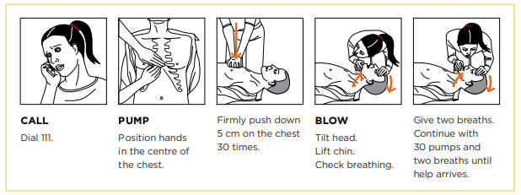
Call 111
Position your hands in the centre of the patient’s chest and push down firmly and quickly 30 times.
- Breathing: with the patient’s head tilted back, pinch their nose and seal your mouth over their mouth.
Blow twice into the patient’s mouth. Take care if poisoning is suspected. Make sure there is no residual poison in the mouth; consider mouth to nose resuscitation.
- Chest compressions: push down on chest firmly and quickly 30 times. Continue with two breaths and 30 pumps until help arrives.
Chest compressions are the most important part of CPR, so, if for any reason you cannot give rescue breaths to a patient, DO attempt chest compressions.

Emergency Response Drill

Site
Date

Evacuation Response Time
Response Time
Alarm sounds
Warden Responses
Warden checks area
Evacuation commenced
Warden reports area clear
Arrive at assembly point
Warden check all workers present
Evacuation completed

 | Yes | No
Was the alarm audible across all areas?
Did workers use the nearest exit?
Did workers leave the area in a calm manner?
Did everyone arrive at the assembly point in a timely manner?

Areas for improvement

Drill observed/ conducted by
Full Name
Signature
Date

Environmental Sustainability Policy

Our goal is environmental sustainability in providing our services to customers in global markets
including transportation, energy, and resources, industrial, infrastructure and commercial services,
and facilities.

OUR COMMITMENT IS TO
- minimise the short and long-term impact of our activities on the environment and local communities through responsible environmentally sustainable management within design, planning, delivery, construction, manufacturing, and operation
- promote a positive culture through implementing initiatives that foster sustainable innovation.
- optimise our products and services to relentlessly improve our environmental sustainability performance and improve the sustainable use of natural resources.
- comply with relevant environmental legislation, appropriate industry guidelines and standards, customers, and regulatory agency requirements
- implement responsible resilient work practices that minimise the impact on local communities
- implement and maintain an environmental management system consistent with international standard AS/NZS ISO 14001 which integrates requirements throughout the overarching operational systems
- establish, monitor, and review environmental sustainability objectives and targets and identify opportunities to improve our environmental sustainability
- evaluate the performance, effectiveness, and compliance of our environmental management systems through regular audits and reviews
- implement effective controls to identify, evaluate, eliminate, or reduce adverse environmental risks from our work activities
- take all practical steps to prevent pollution and protect biodiversity and ecosystems
- drive innovation to identify sustainable supply chains; reduce and manage energy, waste, and water consumption; reduce and manage air emissions and effluents; and climate change mitigation and adaptation
- procure goods and services to minimise environmental risk and maximise sustainable opportunities and benefits for the total life cycle
- regularly report our environmental sustainability performance and consult with stakeholders
- provide education, training and encouragement to our workforce, and business partners to understand their responsibilities for the implementation of environmental sustainability principles and practices; and
- display this policy, making it publicly available and sharing it with interested parties.
Dated and Signed by Officer of PCBU
Event Report

event details
Person involved |  |  |  |  |  |  |  | Location of Incident
Manager |  |  |  |  |  |  |  | Client
Investigator |  |  |  |  |  |  |  | Incident Date and Time
sequence of events Leading up to the event
Date | Approx. Time |  |  |  |  | Event/ Action Description
IDENTIFY EACH PROBLEM AND root CAUSE
- Identify each problem - what went wrong?
- Why went it wrong?
- Root Cause – why did it happen?
Problem |  |  | Why? |  |  |  |  |  |  |  |  |  | Root cause
corrective actions – How to prevent it from happening again?
Root cause |  |  |  | Action detail |  |  |  | Assigned To |  | Due Date |  |  |  | Date Complete
sign-off
Report completed by:  (PRINT name) |  |  |  |  |  |  | Signature |  |  |  | Date
Reviewed by Manager:  (PRINT name) |  |  |  |  |  |  | Signature |  |  |  | Date

Fall Protection for Tools Checklist

 | Yes | No | N/A
Conduct a dropped object risk assessment before performing work where drop hazards may be present.
Ask yourself if you need to be doing a job at height.
Expand fall protection programs to include tools and equipment, including a “competent person” to manage the extended program.”
Consider using tethered tools and closure bags as a primary drop prevention plan.
Make sure that any tool that weighs more than five pounds is not tied off to a person.
Cover gaps in flooring, openings, and grid mesh.
Make sure toe boards can withstand a force of at least 50 pounds in any downward or outward impact.
Consider that something may be dropped or bounced horizontally and
not just straight down. Per OSHA, your drop zone must be 1 meter out for every 4 meters up at a minimum. This may need to be extended as you conduct your risk assessment.
Consider regularly scheduled work zone “hazard hunts” to drive awareness of drop hazards.
Have secure storage areas onsite to encourage tool check-in when not in use.
Secure or tie-down equipment and tools in windy conditions or inclement weather.
Have barricading and warning signs in place to protect lower levels and surrounding areas where objects may fall (hard barricades, danger tape, and information tags, “work above” signs, spotters, etc.).
Communicate with workers and all others on the job site to ensure they are aware people are working above.
As always, ensure hard hats and head protection are always worn on worksites.

Fire Response

- Your first concern in a fire is always your own safety then the safety of others.
- Call emergency services (dial 111) and ask for Fire.
- Contain the fire, but only if it is safe to do so.
If others are safely able to help, send someone to meet the fire engine and direct firefighters to the fire.
FIRE EMERGENCY CHECKLIST
- Raise the alarm.
- Evacuate people from the area.
- Activate emergency shut down systems.
- Call emergency services (dial 111) and ask for Fire. Tell the operator if chemicals are on site or involved in the fire.
- Call your supervisor.
PRECAUTIONS
- Do not endanger yourself.
- Make sure you have an escape route.
- Do not use water on petrol, oil or electrical fires.
- Do not leave the site unattended if there is a risk of further outbreak.
- Advise your supervisor of the incident.

Evacuation/ assembly points
Nearest fire extinguisher
Nearest Phone

Fire

If the fire is too large, do not try to put it out – retreat to a safe distance
1. Raise the alarm by e.g. switching on the fire alarm, shouting, or alerting others
2. Evacuate everyone from the area.
3. If it is safe to do so:
- activate the emergency stop
- switch off power to all equipment
- shut any isolation valves, and
- use your fire extinguisher – contain and extinguish the fire.
4. Call emergency services (dial 111) and ask for Fire. Tell the 111 Operator if there are chemicals on site or involved in the fire. If there are, tell them which chemicals and their quantities. Make sure someone is available to direct Fire and Emergency New Zealand personnel to the scene.

Using a fire extinguisher
- Make sure the extinguisher is the correct type.
- Break extinguisher seal/remove the safety pin. Keep yourself low so you are not overcome by the heat and smoke.
- When you are safely in position, aim the extinguisher at the base of the flames.
- Discharge the extinguisher in a sweeping motion across base of the flames until fire is completely extinguished.
- If the fire becomes uncontrollable, or there is too much heat or smoke to stay safe, leave immediately.
Don’t let the fire block your escape route

After the event
- Complete an incident report and review the effectiveness of the emergency plan.
- If necessary, replace used fire extinguishers

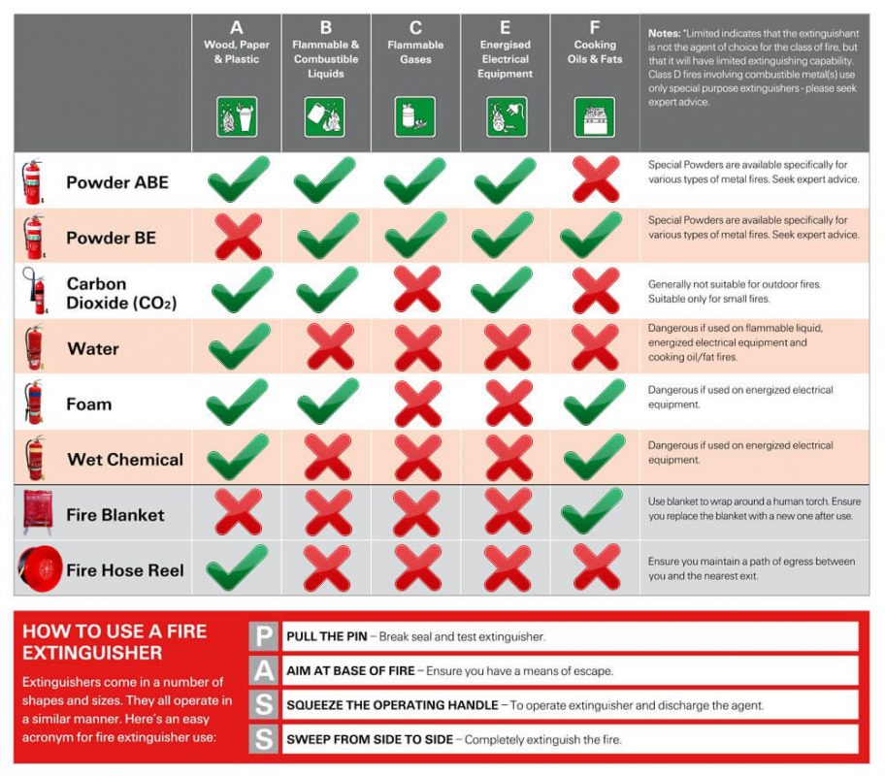

Fitness for Work Policy

Our goal is workers fit (physically, mentally and emotionally) to attend and perform their work
competently and in a manner that does not compromise their health or safety, or the health and
safety of others.
We believe in an integrated approach to the management of fitness for work. Our fitness for
work program consists of:
- fatigue management
- drug and alcohol management
- injury management
- health assessments
- Employee Assistance Program (EAP).

WE COMMIT TO
- a Zero Harm culture that supports fitness for work and a safe working environment
operating in accordance with the legal and regulatory standards of New Zealand
- achieving the highest standards of health and safety by maintaining a drug and alcohol-free
workplace
- informing and educating employees, contractors and visitors on the impact of drugs, alcohol and other issues relating to general well-being and work performance
- monitoring fatigue levels, hours of work and implementing appropriate management programs
- managing injury and illness for employees to return to work in a safe and timely manner
- encouraging employees take periodic annual leave to maintain a work life balance
- providing a confidential (EAP) for the benefit of all employees
- actively promoting exercise, healthy eating and a smoke-free environment to maintain and
improve employees’ own well-being; and
- developing, in consultation with employees, facility-specific programs to address lifestyle, fitness and health, and safety issues.

All Workers share our commitment by presenting for work in a safe and fit manner
promptly reporting any suspected breaches of this policy; and complying with all procedures,
training, and instruction relating to fitness for work.

Signed and Dated by Officer of the PCBU

Emergency Response

- The priority in an emergency your own safety then the safety of others.
- Raise the alarm. If you need to evacuate yourself or others, do so immediately.
- If you need to call emergency services, call them as soon as possible after ensuring the safety of all people present.

Call emergency services (dial 111) and ask for Fire or Ambulance
1. Call from a safe place.
3. Tell the operator which emergency service you want.
4. Wait until that service answers and give the following address:

Company Name
Street name and number
Suburb
Phone number
Where required:
Nearest intersection, cross street, or landmark
Nearest city/ town

5. Let emergency services know if chemicals or hazardous substances are involved in the emergency
or are present on site.
6. Do not hang up until the emergency service tells you to do so.
7. Make sure someone is available to direct the emergency service to the scene

Ground Disturbance Standard

Scope
This following ground disturbance standard focuses on the risk of contact with underground services directly related to excavations (using mechanical or manual methods) and other ground disturbance activities (such as thrusting, directional drilling and piling).
This standard applies to all ground disturbance activities, regardless of depth.
Definitions
Ground Disturbance Any penetration of the ground, regardless of depth, using a tool, plant or other object, such as fence standard or post.
Responsibilities
Underground Services Precautions
Safe Work Methods for ground disturbance where buried services may be present must, so far as is reasonably practicable, include:
- Site assessment to check for visible indicators of the presence of underground services (manholes, lampposts, house-connections, cabinets, etc);
- Obtaining current service plans from all relevant asset owners. This may also identify the need for Close Approach Consent, mandatory stand-over or similar.
- Arranging for mark-out of the full scope of the planned excavation, and all buried services, on the ground to identify potential conflict points.
- Use of Cable Avoidance Tools (CAT), or other detection technology, to assist with locating underground services.
- Potholing using hydro-vacuum excavation, or hand-digging with non-conducting tools and wearing PPE including flame-retardant clothing and eye protection, to confirm the location and line of buried services in proximity to the planned excavation.
General precautions when doing excavation work around underground services include:
- Be wary of the potential exposure to LIVE services when digging, even though nothing is shown on plans. This includes even the simplest of routine or repetitive jobs.
- Never assume that services have been installed at the recommended depth. They are often shallower.
- Don’t rely on finding marker tape or protective covers, and if found do not assume the service will be located directly below.
- Keep a clear lookout for signs of cables and gas pipelines or laterals.

This standard is written with reference to:
- WorkSafe New Zealand Good Practice Guidelines for Excavation Safety;
- NZUAG National Code for Utilities Access to the Transport Corridors; and
- New Zealand Electrical Code of Practice (ECP) 34 – Electrical Safe Distances.

Hard Hat Checklist
Name

Signature

Remember to inspect your hard hat every single day before you start work. It is essential for your safety at work. It only takes a second for an accident to happen which could potentially be fatal, and a hard hat is a solid line of defense if an incident does occur.

 | Pass | Fail | Comments
CHECK IT COMPLIES
Standard AS/NZS 1801:1997
INSPECT ITS SHELL
Inspect the shell of the hat both inside and out – but don’t remove any inner lining to do so.
Check for cracks, burns or general wear, and if any of these are present, remove it from service straightaway.
CHECK THE LINER
Checking the liner is a very simple, yet very important factor in hard hat inspection. You should look for things like cracks, marks, and missing parts. You can remove the comfort pads to get a better look at potential damage, but you should not remove the liner attached to the shell.
INSPECT THE WEBBING (OR CRADLE)
In this step, you will want to check the hard hat’s “cradle,” or webbing. Look for major signs of wear, cuts, burns, or the deformation of plastic pieces within the hard hat. If you notice any of these, remove the hard hat from service.
EXAMINE THE HEADBAND
Don’t forget to examine the headband as well as all headband attachments. Keep an eye out for extreme signs of wear, deformation, and missing pieces. If it is necessary, remove the foam or comfort pads for a better look.
MAKE SURE THE ADJUSTMENT SYSTEM WORKS
Now you should check the adjustment system. When examining the adjustment system, you need to make sure it is functioning properly. This would mean that the crank moves in both directions smoothly, and the device is not missing any pieces.
CHECK THE CHIN STRAP
Check the chin strap to make sure all the pieces are there and that they lock properly. You can check this by clipping the clasps together then lightly pulling to make sure they do not pull apart. You will also need to make sure all the straps are free from wear and damage and that the plastic clasps don’t have any breaks or cracks. If damage is present, it is unusable.
INSPECT THE COMFORT FOAM
If the foam is damaged, it should be replaced. But if the material is just dirty (or crusty), it might just need a wash.

Looking After Your Hard Hat
- Store in a cool, dry environment, away from direct sunlight, heavy or sharp objects.
- Keep your hard hat away from chemicals including paints, paint thinners, solvent based adhesives (some stickers) and cleaning agents.
- Clean by scrubbing and immersing in warm soapy water and rinsing in clean warm water.
- Sweat bands must be regularly replaced as required.
- If the hat loses its glossy finish and appears chalky, the shell must be replaced

Harness Inspection Certificate

Result:

If this certificate states PASS on the result line the item described in this certificate is deemed safe in accordance with relevant AS/NZS Standard 19359, Manufacturer Requirements and Relevant Industry Requirements where applicable at the date of issue.
If this certificate states FAIL on the result line the item described are deemed to be Insafe and/or uncompliant and should be destroyed and disposed of. The owner must ensure equipment is maintained to this level/ condition by performing regular visual and function /checks between required inspection/ service? Calibration periods
Conducted By:

Inspection Comments
Checked Manufacturing Details
Performed 6 monthly and visual inspection

Inspection Result -
Certificate Number
Type of Test
Shock Absorber
Webbing
Stitching
Attachment Points
Buckles and Adjusters
Physical Damage
Applicable Manufacturers Markings

Inspection Details
Certificate Number
User Name
Serial Number
Date Inspected
Next Due Date

Asset Information
Type of Unit | Harness
Date of Manufacture

Hazard Identification Form

Name |  | Date
I have identified the following hazard
How can it harm you, others, or the environment?
What would you like done about it?

Hand the form to your Manager/ Supervisor/ Health and Safety and discuss actions to be taken
What agreed action will be taken?
Hazard needs to be added to Hazard Register | Yes |  | No

Sign Off Date
Worker Full Name |  | Signature
Manager Full Name |  | Signature

Hazard Register
Version #, Date and Review Date

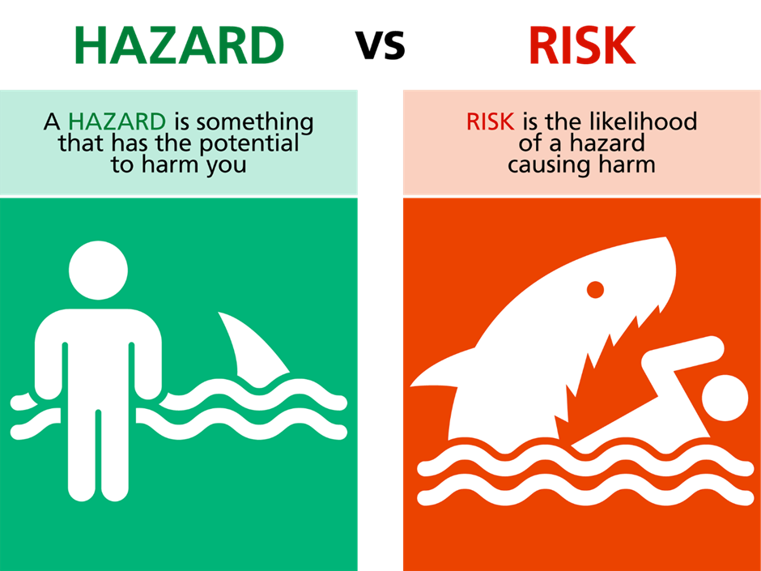

Hazard/ Risk | Initial Risk | Control(s) | Residual Risk

Insert Risk Matrix
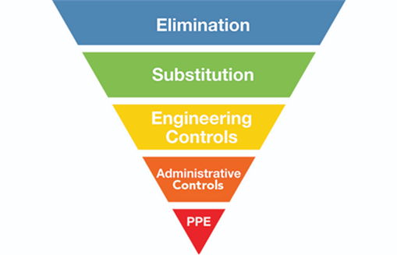

HAZARD REGISTER
Date and Review Date

Safety Hazards | Risk(s) | Risk Rating | Control(s) | Control Effectiveness | Comments

Chemical Hazards | Risk(s) | Risk Rating | Control(s) | Control Effectiveness | Comments

Biological Hazards | Risk(s) | Risk Rating | Control(s) | Control Effectiveness | Comments

Ergonomic Hazards | Risk(s) | Risk Rating | Control(s) | Control Effectiveness | Comments

Psychosocial Hazards | Risk(s) | Risk Rating | Control(s) | Control Effectiveness | Comments

Physical Hazards | Risk(s) | Risk Rating | Control(s) | Control Effectiveness | Comments

Pick or Create a Risk Matrix
Pick or Create “control effectiveness” matrix

Hazardous Substances Inventory

Name of Inventory
Date

Name of product and UN number | Approval number and group standard name (if applicable) | Hazard classification (UN class and packaging group) | Current SDS available? (not older than 5 years) | Specific storage and segregation requirements | Container size | Open or closed container? | Gas, liquid or solid? | Location | Maximum likely amount

Health and Safety Policy

We are committed to health and safety and will ensure, so far as reasonably practicable, the health and safety of all our workers and other persons who may be put at risk from our work. We will address this duty of care by, so far as reasonably practicable:
- Complying with the Health and Safety at Work Act 2015 (HSWA) and Health and Safety at Work (General Risk and Workplace Management) Regulations 2016, standards, relevant codes of practice and guidelines.
- Providing and maintaining a work environment or work premises that are without risks to health and safety.
- Providing and maintaining safe plant, machinery and equipment and structures.
- Providing and maintaining safe systems of work.
- Ensuring the safe use, handling, storage, and transportation of hazardous substances.
- Providing and maintaining adequate facilities for the welfare of workers.
- Monitoring of the health of our workers and the conditions on site (workplace) to prevent illness or injury.
- Providing any information, training instructions or supervision necessary to protect our workers from the risks relating to their work.
- Ensure all contractors are suitably qualified to undertake the work for which they are engaged.
- Accurately reporting and recording all sites (workplaces) events (injury/illness/incident/near miss).
- Consulting with and encouraging the participation of other duty holders, our workers and their representatives on matters affecting health and safety.
- Ensuring appropriate processes are in place for receiving, considering, and responding in a timely manner to information regarding incidents, hazards, and risks.
- Providing safe means of access and egress to and from places of work.
- Reviewing, revising, and evaluating our health and safety management systems and processes at regular intervals to ensure continuous improvement; and
- Supporting the safe and early return to work of injured workers.

Management acknowledges and accepts its responsibilities for health and safety standards on site (workplace). However, we seek cooperation from all workers in achieving our health and safety objectives and expect that workers will:
- Take reasonable care for their own health and safety.
- Take reasonable care they do not adversely affect the health and safety of other persons.
- Follow our policy and procedures.
- Comply with any reasonable instructions given.
- Identify hazards, assess, and control risks to health and safety that are under their control.
- Use any Personal Protective Equipment (PPE) provided; and
- Report all hazards, accidents, and incidents (events) to their supervisor in a timely manner.

Insert date and signature of officer of the PCBU

Incident and Hazard Report Register

Date and Time | Details:  - Name of Person  - Brief Description of what happened  - Cause of harm (if any)  - Type of Injury (if any) | Immediate Action Taken/ Corrective Actions | Notifiable Event (Y/N) | Date of WorkSafe Notification | Investigation Report completed (attached to Register) | Investigation outcomes discussed at toolbox on:

Informal Reporting of Unreasonable behaviour
This form is to informally report behaviour that has upset you

Name

What has happened?
Time | Date
Location

Who was present?

What happened?

Who did what?

How did this behaviour make you feel?

How has this behaviour affected your work?

Have you taken any actions? If so, what?

As a result of this report, what do you want to happen?

Please give this report to (insert appropriate person in business or undertaking)

Injury Management Policy

Our goal is Zero Harm and the management of injury to all employees with work-related
injury or illness.

OUR COMMITMENT IS TO
- take a progressive, integrated, and multi-disciplinary approach to caring for our people
- provide injured or ill employees with information and assistance regarding their rights and responsibilities in relation to their return to work
- engage with our employees to provide timely and quality rehabilitation and return to work programs, which commence as soon as possible after an injury or illness has occurred
- provide suitably qualified and experienced persons to undertake injury management and return to work coordination duties; assist injured or ill employees to stay at or return to work safely at the earliest opportunity
- assist employees to identify suitable duties which are consistent with their assessed medical requirements to facilitate their safe and effective return to work
- consult with injured or ill employees, their supervisors, and key stakeholders, including treating practitioners concerning treatment and work arrangements; and
- meet our legal obligations and the requirements of external parties, including our customers, insurance partners and regulators, and
- review this policy and accompanying procedures as required to continue to provide the most effective and timely information and support to our workers and to meet jurisdictional and legislative requirements.

All our workers share our commitment by presenting for work in a safe and fit manner,
complying with instruction, procedures, training, and supervision, promptly reporting
injuries and illnesses; and actively participating in, and cooperating with, their return to work and
injury management programs.

Date and Signed by Officer of Company

Job-Start Form

Site Address: | Date: | Time:
Conducted by: | Signature:

Take 5 - Stop, step back, observe - Think through the task - Identify any hazard - Control the hazard - Complete the task safely

What can harm me?  What can harm others?  What can harm the environment | Controls required to reduce the risk of harm to me, others, or the environment? | Who is responsible for implementation of control(s)? | Completed? Initials

Job-Start Form

Site Address: | Conducted by:
Job Reference Number:
Date: | Time:

Check before each job
Site Induction Completed |  | Correct PPE worn
Tool(s) has valid tag |  | First Aid Kit available on site
Fire Extinguisher

Site Specific Hazards and additional controls needed

Plan of work area

Full Name | Signature

Daily Ladder Inspection Checklist

Ladders are primarily a means of access to carry out light tasks that are of short duration, for example changing a light bulb or touching up paint. They do not offer any protection from a fall. Consider control measures when selecting the best way to work at height.
- Eliminate the chances of a fall by doing as much preparation work as possible on the ground.
- Minimise the risk of a fall by taking actions to prevent it. For example, isolate the worker from the risk by using scaffolds and edge protection

Please complete checklist using YES, NO or N/A
Check the environment – only use on firm and level ground. If there is a chance of the stepladder being struck by plant or vehicle relocate the ladder and if this is not reasonably practicable protect the area using suitable barriers or cones. Use commercially available levelling devices, not ad-hoc packing
Check for overhead powerlines – make sure not to work within 4m of low voltage overhead powerlines without additional controls e.g., tiger tails
Check the ladder is suited to the task - rating, height, type, material etc.
Check the ladder is rated for trade or industrial use - with “ASNZS 1892” label present
Check the rails/stiles – make sure they are not bent or damaged, as the ladder could buckle or collapse.
Check the feet – if they are missing, worn or damaged the ladder could slip. Also check the ladder feet when moving from soft/dirty ground as the stability of the ladder may be affected by the accumulation of dirt/mud on the feet.
Check the rungs – if they are bent, worn, missing or loose the ladder could fail.
Check any locking spreader mechanisms – if they are bent or the fixings are worn or damaged the ladder could collapse. Ensure any locking bars are engaged.
Check the stepladder platform – if it is split or buckled the ladder could become unstable or collapse.
Check the treads on stepladders – if they are dirty/worn they could be slippery.
Check the step fixings - If the fixings are loose on the steps they could collapse.

If you spot any damage, don’t use the ladder, and tell your supervisor/manager and tag it out of service!!!
Sign off
Name |  | Date

Lanyard Inspection Certificate

Result:

Inspection Result
Certificate Number
Type of Test
Tail Material
Shock Absorbers
Webbing
Function
Hardware
Stitching
Buckles and Adjusters
Physical Damage
Applicable Manufacturers Markings

Inspection Comments
Checked Manufacturing Details
Performed 6 monthly and visual inspection

If this certificate states PASS on the result line the item described in this certificate is deemed safe and compliant with WorkSafe NZ and Manufacturers’ requirements at the date of issue.
If this certificate states FAIL on the result line the item described is deemed to be unsafe and/or uncompliant and should be destroyed and disposed of.
Conducted By:

Asset Information
Type of Unit | Lanyard
Manufacturer

Model

Date of Manufacture
Remove from Service Date

Inspection Details
Certificate Number
User Name
Serial Number
Date Inspected
Next Due Date

LPG leak response
This also applies to other flammable gases (not to toxic gases)

- Your first consideration is the immediate safety of all people present.
- If you suspect a flammable gas is leaking, move away from the likely source of the leak before using a mobile or cordless phone.
- Evacuate, and if necessary, call emergency services (dial 111) and ask for Fire.
- If safe to do so, isolate or turn off the gas at the source.
- If others are safely able to help, give them tasks to help manage the leak.

GAS LEAK CHECKLIST (BULK FACILITY)
Follow these steps only if safe to do so:
1. Raise the alarm.
2. Evacuate all people from the area.
3. Activate any emergency shut down systems.
4. Activate any water spray protection systems.
5. Call emergency services (dial 111) and ask for Fire. Tell the 111 operator that you have a gas leak, and if able, tell them what the gas is.
6. Call your supervisor.

PRECAUTIONS
- Do not endanger yourself.
- Make sure you have an escape route.
- Keep your hands and face clear of any escaping gas or liquid.
- No smoking! Keep ignition sources at least 20 m away until the area is safe.
- Do not use the equipment again until it has been inspected.
- Do not leave the site unattended if there is risk of a further leak.
- Advise your supervisor of the incident. If the leak exposes workers or anyone else to a serious risk to their health and safety, notify WorkSafe.

Evacuation/assembly points

Location of the nearest phones

Maximum amount of LPG held on site
Please enter information about the maximum amount of LPG you hold on site (e.g., size of tank, volume of system)

Suspected LPG cylinder or appliance leak
- First, if there is any possibility of cylinder(s) being engulfed by fire, evacuate all surrounding areas.
- Then, call emergency services (dial 111) and ask for Fire. Advise them of a suspected LPG leak, the location of the cylinder or appliance and the cylinder size.
- Remove or extinguish all sources of ignition.
- If it is safe to do so and possible:
  - remove the cylinder or appliance from any heat sources
  - stop the leak by shutting the cylinder valve, and
  - remove the cylinder or appliance to a safe outdoor area, if the leak persists
  - DO NOT attempt any of the above if you are not completely sure of what to do.
- If gas is leaking, ventilate the area thoroughly until the air is clear.
- If it is a minor leak, check the system for any indication of gas leaking, such as a smell or hiss.
- Test with a soapy water solution, which will bubble at any point where gas escapes.
- If a leak is found at a connection, remake the connection, and test it again.
- Do not use the cylinder or appliance again until it is inspected.
- If necessary, notify WorkSafe (if the leak exposes workers or any other person to a serious risk to their health and safety).
Bulk storage system leak
- Activate the alarm, evacuate the area.
- Call emergency services (dial 111) and ask for Fire. Tell the 111 Operator that you have an LPG leak from a bulk storage system, and how much the tank or system holds.
- Remove all sources of ignition.
- Activate any fire protection systems.
- If it is a pipeline leak, close isolation valves if it is safe to do so.
- If necessary, notify WorkSafe (if the leak exposes workers or any other person to a serious risk to their health and safety).
After the event
- Complete an incident report.
- Review the effectiveness of the emergency plan.
- Check and reset emergency protection systems, as necessary.

Manual Handling Control Form

Site Address

Manual handling task identified

Date

Time

Person Conducting Assessment

 | Yes | No
Bending, twisting, stretching, overreaching
Lifting, pushing, pulling
Carrying or holding over time or distance
Jerky uncontrolled movements
Cramped workspace
Weights lifted > 4.5kg or 16-20kg standing
Can’t be held close to the body
Repetitive movements
Staff insufficient, unfit, or untrained in work demands
Lifting aids not helpful or available
Unsuitable protective equipment
Unsuitable work heights
Poor housekeeping, temperature, or lighting
Poor housekeeping, temperature, or lighting
Awkward to handle

Mental Health & Wellbeing Policy
This document outlines the policy for mental health and wellbeing.

We acknowledge that the mental health and wellbeing of our employees is a core component of our Health and Safety commitment and thus key to our organisational success and sustainability.

OUR PURPOSE
Our purpose is to provide for the mental health and wellbeing of our employees.

OUR OBJECTIVES
To achieve our purpose, we will:
- Foster a workplace environment and culture that supports and values wellbeing and mental health
- increase employee knowledge and awareness of wellbeing and mental health providing educational opportunities
- reduce stigma around mental health within our various workplaces
- expose employees to a range of initiatives that support their wellbeing and mental health
- provide our workers with workplace practices that support wellbeing and mental health
- provide quality mental wellness support services
- empower management to support the aims of our policy and the promotion and provision of wellness; and
- provide wellbeing and mental health initiatives.
All our employees share our commitment by:
- supporting and contributing to Downer’s aim of providing a mentally healthy and supportive environment for all workers
- understanding and supporting our mental health requirements, practices, and initiatives
- supporting fellow workers in their awareness of mental wellness in the workplace
- taking reasonable care of their own health and wellbeing, including both physical and psychological health; and
- taking reasonable care that their actions do not affect the wellbeing, mental health, and safety of others in the workplace.

Signed and dated by officer of PCBU

Monthly Toolbox Meeting Minutes

Conducted by:
Time and Date:
Present:

Apologies:

Main topic discussed

Other topic(s) discussed

Health and Safety

Monthly Vehicle Inspection Checklist

Please complete checklist using YES, NO or N/A
Vehicle Details
Rego |  | WOF due
Rego expiry |  | Odometer
RUC expiry |  | Service due Km

Plant Check
Oil Level |  | Trailer Coupling
Coolant Level |  | Brakes
Wipers/ Washers |  | Handbrake

Light Checks
Taillights |  | Day lamps
Indicators |  | Brake lights
Head lights |  | Reflectors

Tyre Checks
Tread |  | Wheel nuts
Inflation |  | Mudflaps
Damage

Other Checks
Windscreen |  | Company branding
Reverse camera |  | First Aid Kit
Reverse alarm |  | Fire extinguisher
Seatbelts

Comments

Sign off by person having completed this form
Name |  | Date
Employee Induction
WELCOME TO THE TEAM

Employee Name

Address

Emergency Contact

Position

Supervisor

I have been introduced to:
- My Supervisor/Manager
- The rest of the Team
- Key jobs, tasks, and responsibilities

HEALTH AND SAFETY

I have been shown and explained:
- The hazards register and controls for my job
- The office H&S wall
- How to safely use/store and maintain safety equipment, machinery, and tools
- How to safely perform my job and have been shown what Personal Protective Equipment (PPE) I must wear while doing my work and how to use it.
- The locations of the First Aid Kit(s)
- Material Safety Data Sheets and SOP (where applicable)
- Safe work methods statements relating to my job
- My rights and responsibilities under the HSWA 2015
HAZARDS

I know and understand the importance:
- To check for hazards on every site before starting work and to record that Hazard ID on the job-start meeting form
- To check the warnings on work orders (Kainga Ora jobs only)
- To report any hazards that are not identified on the work order (Dogs, ASB etc.)
- What the controls are for these hazards
- To report any new or critical hazards immediately

INCIDENTS AND INJURIES

I know how to and the importance of reporting the following:
- Injuries/ near misses and signs of early discomfort
- Accidents and any damage to property
- Anti-Social Behaviour experienced on site
- I know reports will be investigated and I will be kept informed of the results
SICK OR INJURED
I understand I will:
- Immediately contact my Supervisor/Manager
- Maintain communication with my Supervisor/Manager throughout time off with injury/illness
- See a preferred Company Doctor (if applicable) for work injuries
- Let the Medical Provider know about return-to-work processes and suitable alternative duties
- Provide medical certificates in a timely manner
- Provide written consent before my employer discusses my rehabilitation with the Medical Provider
- Discuss any barriers disrupting my return to work with my Supervisor/Manager
- Actively participate in any rehabilitation and support provided by the employer
- Return to suitable alternative duties or modified duties if unable to continue normal role with medical clearance
- Work together with the employer to enable a safe and sustainable return to work
EMPLOYMENT CONDITIONS
- I have received 2 copies of my employment agreement signed by the Director
- I had enough time to read through it and get independent advice
- I have returned one signed copy to 09 Building

Additional Comments

Employee (Print Name)
Signature
Date

Permit to Work

Permit Details
Project |  | Permit Number
Permit Issuer |  | Contact Number
Permit Receiver |  | Contact Number
Details of work to be completed

Type of Permit
Ground Disturbance |  | Isolation
Working at Heights |  | Live Works
Hot Works |  | Excavation
Confined Space

Permit valid from | Date: | Permit Expiry  (max 1 week) | Date:
Permit valid from | Time: | Permit Expiry  (max 1 week) | Time:

Training and Competency
Full Name | Training | Expiry

Scope of Works

Controls to be Implemented

Emergency Response Plan

Work authorisation
Permit Issuer – The controls to be implemented are sufficient to control the risk associated with the work carried out under this permit.
Signed |  |  | Date and Time
Permit Receiver – I understand I have to implement the controls as set out in the permit to work.
Signed |  |  | Date and Time

Sign on/ off Register
By signing below, I confirm that I:
• have read and understand the scope of this permit; and
• will comply with my responsibilities under this permit, and all reasonable instructions from the permit issuer.
Full Name | Signature | Time on | Time off

PPE Issue Register

PPE Type | Brand | Model | Condition (new, good, fair) | Date Issues | Issued by | Issued to | Expiry Date (if applicable) | Employee Signature | Comments

Restricted Items Register

This Register specifies items that have been identified as posing an increased risk. The intent of this Register is to ensure awareness of items that are not to be brought on to or routinely used on our sites. A secondary aim is to promote the identification of alternative lower risk items.

Reference Image | Restricted Item | Justification | Alternatives for Consideration | Application of the Exemption Request Process

Safe Work Method Statement

Version & Date, Review Date

Job Type |  | Site Contact
Address |  | Date
Reference Number |  | Client

PPE required: | Uniform | Footwear | High Vis | Hard Hat | Eyewear | Fall Arrest | Gloves | Hearing | Fitted P2 Mask
PPE required: | 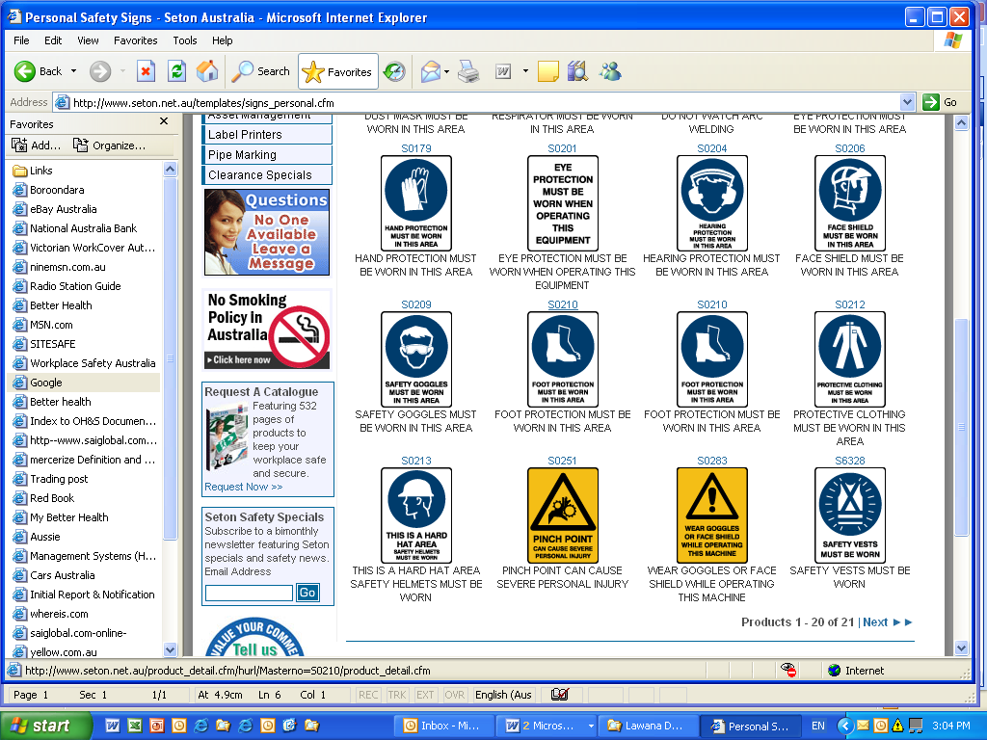☐ | ☐ | ☐ | ☐ | 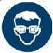☐ | 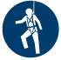☐ | 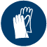☐ | 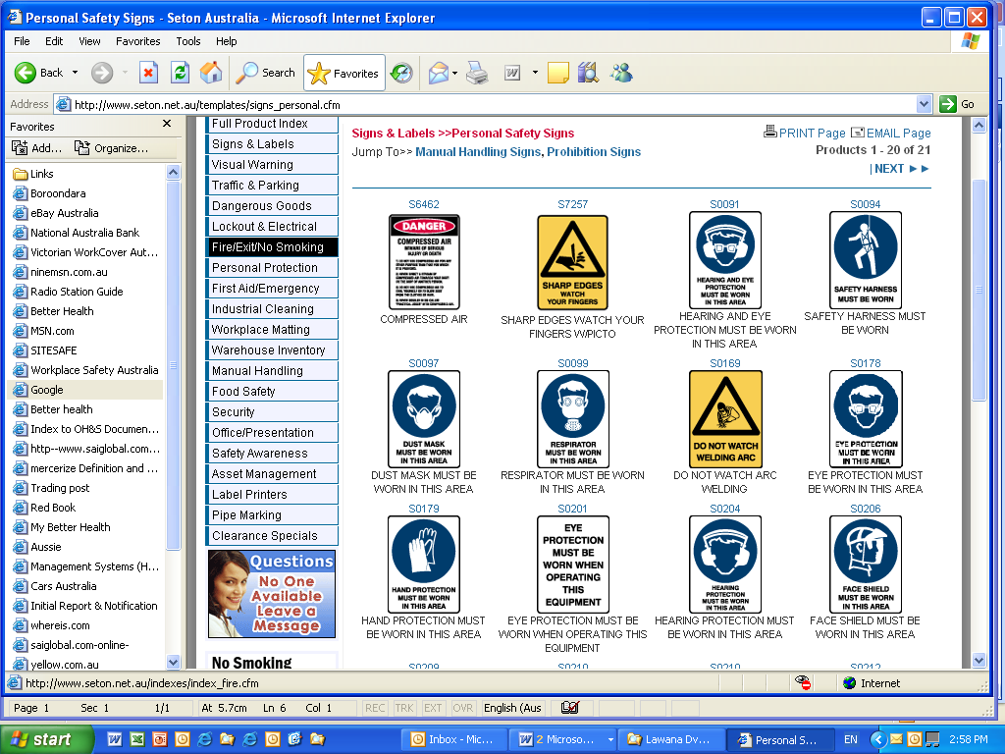☐ | ☐

Job Step | Hazard/ Risk | Initial Risk Rating | Control(s) | Residual Risk | Person Responsible

This SWMS is written with reference to:
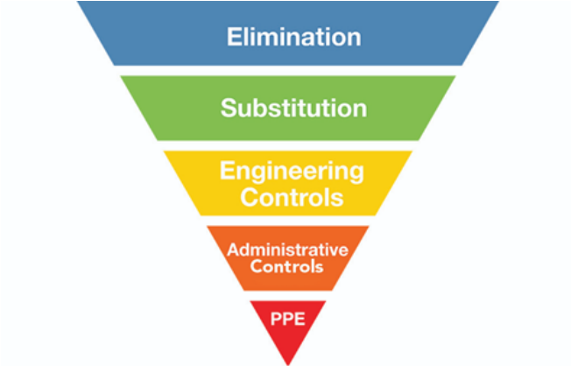

PICK A RISK MATRIX

By signing this SWMS, I confirm that I have been consulted in developing this SWMS and have been given an opportunity to give feedback and ask questions. I confirm that I have read, understood and accept the SWMS and its contents and will follow it while doing work on site.

Full Name | Date | Signature

Safety Alert
Insert: Title, date and if required version number

What Happened?

Insert a simple description of what happened…
Insert a Photo of impact if possible

What did we learn?

Explain findings and lessons learned?
What do we expect people to do to prevent this from happening again?
New control(s) required to control hazards?
Additional PPE required?
Items to be banned from site/ office/ workplace?

Prepared by:
Authorised by:

Additional Information: E.g., WorkSafe guides

Scaffold – Site Assessment

To undertake a site assessment, consider the following:
- What is the purpose of the scaffold, and who will be using it?
- What is the nature of the ground, surface, or structure on which the scaffold is to be erected? Does it need to be verified for load-bearing capacity?
- How will the scaffold be stabilised from overturning? If it will be tied to a structure, how will this be done?
- Will the scaffold be subject to environmental loads such as funnelling wind, vehicle impact, or snow?
- How will workers and vehicles access the site and the area for storage of material and equipment?
- Does the scaffolding create risk for workers on or around it?
- Are there electrical conductors or cables near the scaffold? Could the scaffold or workers meet them at any stage of the scaffolding process? That could include delivering scaffolding equipment to the site, erection, associated scaffolding use and work activity, and eventual dismantling/removal from site.
- Is there enough space to erect the scaffold and store scaffold materials?
- Is the scaffold to be erected on a public roadway or footpath, and what are the local authority requirements?
- How will the site be protected from unauthorised access?
- Is pedestrian access through the site required? How will this be managed?
- Is a specific traffic management plan required?
- Are there any other potential hazards specific to the site?
- Does the work need to be notified to WorkSafe?

Planning considerations should include discussions on:
- permits/consents/notifications
- service mark-outs and locations
- site-specific documentation which could include:
  - health and safety policy
  - summary worksite safety plan
  - worksite emergency procedures
  - worksite safety induction card
  - visitor and worksite induction register
  - accident/incident register, including near misses
  - injury/ill-health/incident reporting
  - hazard identification
  - site-specific risk assessment
  - safe or standard operating procedures
- quality plan
- overhead services and underground service plans
- construction plans
- nature or condition of the ground
- weather conditions (e.g., time of year, expected conditions, etc.)
- interaction with other PCBUs
- site access and security
- traffic management and public safety
- type of plant and equipment to be used
- provision of adequate facilities for workers

Scaffold Checklist

All scaffolds are to be inspected and signed off by the appointed scaffold inspector before use and weekly thereafter, or after inclement weather, displacement, or modification.
Address/ Site
Company Name
Name of Inspector

ITEM TO BE INSPECTED | DATE OF INSPECTION
1. Foundations
1.1 Ground Level
1.2 Base jacks or wheels
1.3 Wheel locks
2. Bracing
2.1 Bracing
2.2 Tie bars
3. Frames
3.1 Frames straight (not twisted)
3.2 Joint welds in good condition
3.3 No excessive rust
4. Guard Rails
4.1 Guard rails all around platform
4.2 Properly fixed to frame
5. Ladder
5.1 Hook on ladder secured
5.2 Good condition
5.3 900mm above platform
6. Platform
6.1 Full width platform
6.2 Steel hook on boards used
6.3 Toe boards used
6.3 Boards in good condition
7. Signage
7.1 “Safe to Use” or “Unsafe to Use” signs and warning signs
Scaffold Inspector Signature
Construction Supervisor Signature

Scaffold Handover Certificate
The scaffold hand-over certificate releases the scaffold(s) to the client. The scaffold(s) have been inspected by the client and has been erected to the client’s requirements. All scaffolds have been erected as per the requirements of the Good Practice Guidelines for Scaffolding in New Zealand.

Client

Location

Description

Comments (special conditions)

Authorised client (print name) | Signature | Date
Scaffolding representative (print name) | Signature | Date

Scaffolding over 5.0 m high is notifiable work and the erection/dismantling or alterations including the movement of planks, can only be carried out under the supervision of a Scaffolder holding a current Certificate of Competency

Scaffold notified to WorkSafe | Yes |  | No
Number of lifts fully planked with full edge protection

Ladder/ stair access bays to all working lifts

Screening

Scaffold register location

Light duty  225 kg per bay | Useable lifts per bay |  | Limitations
Medium duty  450 kg per bay | Useable lifts per bay
Heavy duty  675 kg per bay | Useable lifts per bay
Special duty | Useable lifts per bay

Self-Report of Discomfort

Employee Name: ___________________________________________________________________
Position: __________________________________________________________________________

Describe the problem and how it feels (e.g., aching, painful, tight) – also include what makes it feel worse/ better and what it is like when NOT at work.
________________________________________________________________________________________________________________________________________________________________________________________________________________________________________________________________________________________________________________________________________

Mark the areas most affected on the body diagram
- Next to each area write the number that shows the severity of the discomfort or pain you feel. (severe pain (1), pain (2), mild pain (3) or discomfort (4))
- And the letter that indicates how long you have been noticing it there (always present (A), only while at work (B), improves after a night rest (C), occasional (D)

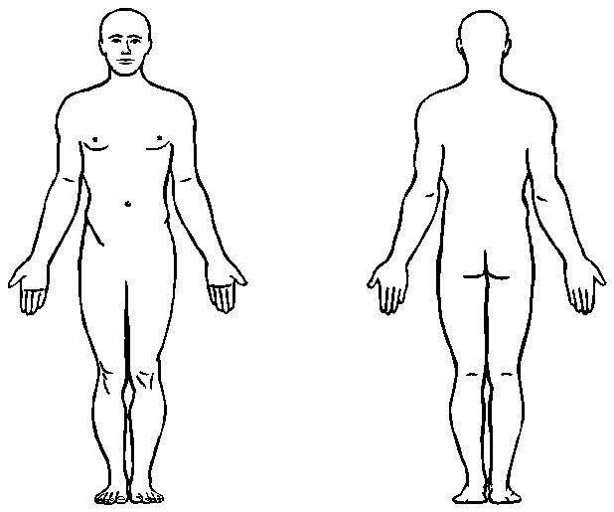

When did you first notice the discomfort/ pain? ___________________________________________
Is the problem (tick one)? O getting worse O getting better O remaining the same

Signed: ___________________________________________________________________________
Today’s Date: ____________________________________________________________

Site Inspection Checklist

Yes | No | N/A
 |  |  | Public Safety – Barriers and Hazard Board are in Place
 |  |  | PPE – Correct PPE is worn, suitable to the task and in good condition
 |  |  | Inductions – everyone on site has been inducted to site
 |  |  | Training – all workers are trained and/ or competent for the work they are doing OR supervised
 |  |  | Emergency Procedure – relevant to task/ risk is available on site and understood by workers
 |  |  | Hazardous Substances – Safety Data Sheets are available to workers; correct PPE is worn and controls in place
 |  |  | Vehicles – are parked in accordance with site requirements
 |  |  | Housekeeping – site is tidy and without any slip or trip hazards
 |  |  | Particular Hazardous Works – have been notified to WorkSafe at least 24h I advance
 |  |  | Ladders – have been checked and are being used by a competent person in a safe manner
 |  |  | Tools – have been tagged, inspected before use and are being used by trained and/ or competent person
 |  |  | Noise – where noise has been identified as hazard, appropriate hearing protection is worn
 |  |  | Lighting – is sufficient in the work area
 |  |  | Scaffolding – has been erected and checked by competent or qualified person
 |  |  | Working at Heights – suitable fall protection is used by competent or trained person
 |  |  | Falling Objects – where there is a risk of falling objects, appropriate controls are in place

Spill response

- Your first consideration is the immediate safety of all people present.
- Call emergency services (dial 111) and ask for Fire.
- If safe to do so, contain the spill.
- If others are safely able to help, give them tasks to help manage the spill.

Evacuation/ assembly
Nearest Phone

A major spill is
- any amount of flammable, very toxic products or products that need tracking
- anything with a product label says EXTREMELY FLAMMABLE, FATAL, TOXIC, OXIDISER or CORROSIVE
- more than 200L of any other chemical or spill.
A minor spill is
  - a spill involving 200L or less of any other chemical or fuel.

SPILL CHECKLIST
1. Raise the alarm.
2. Evacuate people, if necessary.
3. If the spill involves a flammable substance, move away from the spill before using a mobile or cordless phone.
4. Call emergency services (dial 111) and ask for Fire. Tell the 111 Operator that you have a chemical spill and if you can, tell them what the chemicals are, and the quantities involved.
5. ONLY if it is safe to do so close the valve, plug the leak or turn the container upright.
6. Use safety equipment to contain the spill. Prevent the spill from entering drains or waterways.
7. Call on specialist advice.
8. Clean up the spill.
9. Recover the product or dispose of the waste safely.

PRECAUTIONS
- Do not endanger yourself.
- Wear personal protective equipment appropriate for the spilled substance (e.g., suitable gloves, protective eyewear, suitable protective clothing).
- Do not leave the area unattended if there is risk of a further spill.
- If the spill is likely to enter a waterway then notify the local council.
- Advise your supervisor of the incident. If the spill exposes workers or anyone else to a serious risk to their health and safety, notify WorkSafe

Hazardous substance spills
Raise the alarm by e.g., switching on the fire alarm, shouting
- Identify the nature of the spilled substance only if you can do so without putting your safety or anyone else’s safety at risk.
- Evacuate and if necessary, call emergency services (dial 111) and ask for Fire. Tell the 111 operator that you have a chemical spill and if you can, tell them what the chemicals are, and the quantities involved.
- Put on personal protective equipment (e.g., overalls, boots, gloves, eye protection).
- Close off the source of the spill if it is safe to do so.
- Remove sources of ignition if a flammable substance has been spilled.
- Identify the dangers posed by the spill – only respond if it is safe to do so.
- Refer to the safety data sheet (SDS) or call a certified handler or other specialist for advice.
- Where can safety data sheets be found?
  - Enter Location
- If necessary, advise the local council (if the spill is likely to enter a waterway) and WorkSafe (if the spill exposes workers or any other person to a serious risk to their health and safety).
- Use your spill kit if it is appropriate for the spill and safe to do so. Contain the spill by using a drip tray, oversized container, or an absorbent to soak up a small spill.
- Dispose of waste safely according to the instructions on the safety data sheet and any district council rules for disposing of hazardous waste.
Oxidisers
- Apply the following measures to keep liquid/liquefied oxidisers or organic peroxides away from incompatible substances:

After the event
- Replenish your spill kit.
- Complete an incident report.
- Review the effectiveness of the emergency plan.

If you have hazardous substances, you need to have a plan for containing any spill and know how you are going to clean it up.
A major part of this involves having a spill kit. A spill kit contains the equipment and materials you will need to clean up a spill. Some of the equipment will depend on the type and amount of chemicals you have. You can buy spill kits from safety equipment suppliers or you can assemble your own.
What to put in your spill kit?
- Personal Protective Equipment (PPE) such as gumboots, gloves, overalls, goggles, and respirators. You should have enough PPE for the number of workers you might need to manage the spill.
- Spill containment equipment such as drip trays, drain guards and barriers.
- Spill handling equipment such as a broom and plastic shovel.
- Absorbent materials such as dry sand, vermiculite, zeolite, or spill containment socks.
- A leak-proof container to put the waste in for disposal.
Absorbent materials
- Absorbent materials should be inert, so they do not react with the chemicals being cleaned up.
- Vermiculite and zeolite work well and do not cost much. You can buy them from
your safety equipment supplier or from DIY or garden retailers (vermiculite is used in gardening and horticulture, and zeolite is sold as kitty litter and BBQ absorbent material).
- Absorbent material should absorb around half of their volume of liquid.
- You should have enough absorbent material for your largest containers that
do not need to be kept in secondary containment.
Spill containment socks
Spill containment socks are fabric tubes containing absorbent materials, such as vermiculite, which are used to soak up spills before they spread or to help prevent spills reaching stormwater or drainage systems. You can buy them from your safety equipment supplier or make them yourself from hessian or canvas.

Standard Operating Procedure (SOP)
Insert Name of Tool or Equipment

Insert warning e.g. DO NOT operate unless Pre-Start check has been completed
Approved safety glasses must always be worn
Insert required Personal Protective Equipment (e.g. safety glasses as above)

Mandatory Pre-Start checks:

How to safely operate tool or equipment:

Potential Hazards:

Housekeeping (where applicable):

Training and Competency Register

Name | Position | Training, Qualifications, Experience |  | Competency
Name | Position | Inductions, Trade and Skills Training | Formal Qualifications, Certificates, Licenses, and Unit Standards

When disaster strikes

Turn on your radio for advice and information.
Know the civil defence warning signal.
Know your nearest civil defence post and police station.
Do not go sightseeing or make unnecessary trips to affected areas.

Civil Defence
Your civil defence warning signal
Your nearest civil defence post
Your nearest police station
Your local radio station
Your civil defence cabinet/kit is located

Earthquake
During the earthquake:
- Keep calm.
- Stay indoors, where practical.
- Keep away from windows and heavy furniture.
- DROP, COVER, HOLD. Get under something that covers you, like a strong table or other sturdy structure. Hold onto it if you can.
- IF IT’S LONG OR STRONG, GET GONE. If an earthquake makes it difficult to stand up, or if an earthquake lasts a minute or more and you are in a tsunami zone, head inland or for higher ground immediately.
After the earthquake, if the building is damaged:
- Turn off gas at the mains. Before you turn off electricity and water, think about if gas detection, fire suppression and alarm systems need these services.
- Conserve your water.
- Treat injuries.
- Get in touch with neighbours – they may need help. If you have one or are part of one, activate your call tree (a list of people and their contact details, where each person contacts the person below them in an emergency).
- When help is needed, go to your nearest civil defence post.
- If any other emergency in this flipchart is likely as a result of the earthquake and ONLY if it is safe to do so, carry out the steps listed for that emergency.
- Advise your supervisor of damage or injury sustained.

Tsunami
This business is in a tsunami risk zone | Yes |  | No

Warning systems
If the earthquake is LONG OR STRONG GET GONE.
Immediately go to high ground or as far inland as possible. Your route to a safe location

- Do not go sightseeing.
- Listen to the radio for information and follow civil defence instructions.
- If any other emergency in this flipchart is likely as a result of the tsunami and ONLY if it is safe to do so, carry out the steps listed for that emergency.

Disease outbreak
- If you are sick then stay home, keep away from other people and avoid receiving visitors.
- Wash and dry your hands when handling food, using the bathroom, wiping children’s noses or if you are looking after sick people.
- Use tissues to cover coughs and sneezes, throw used tissues in a bin and wash your hands.
- Give fluids to people with a fever and/or diarrhoea.
- Paracetamol can be used to bring down high fevers.
- See the Ministry of Health website: www.health.govt.nz

Volcanic eruption
Warning system

BEFORE A VOLCANIC ERUPTION
Your route to a safe location:

DURING THE VOLCANIC ERUPTION
- Stay indoors as much as possible.
- Save water as early as possible as supplies may become contaminated.
- If it is safe to do so, keep gutters and the roof clear of ash to prevent your roof collapsing.
- If you must go outside, use protective clothing, cover your head, breathe through a mask and carry a torch.
- If any other emergency in this flipchart is likely as a result of the eruption and ONLY if it is safe to do so, carry out the steps listed for that emergency.

Flood
- Be prepared to get to high ground.
- Turn off electricity and gas supplies.
- Do not go into floodwaters alone.
- Do not go sightseeing.
- Do not drink floodwater.
- Move valuables, clothing, food, and medicines above likely reach of floodwater, if it is safe to do so.
- Avoid back flow from drains and toilets – fit bungs (stoppers) or sandbags and weigh them down.
- If any other emergency in this flipchart is likely because of the flood and ONLY if it is safe to do so, carry out the steps for that emergency

Witness Statement Record

Incident Details
Incident Date and Time |  | Statement Date
Statement made by |  | Position
Contact Details

Your involvement

Use short, simple sentences and tell your story in the order it happened. Sign your statement in section 3 and initial every page where indicated.

Incident Statement

Incident Map

Person Completing the Statement
Full Name |  | Signature |  | Date
Person Witnessing the Statement
Full Name |  | Signature |  | Date

Working at Heights Rescue Procedures

This document is intended to provide guidance for developing site-specific working at heights rescue plans.

Company Policy on Working at Heights Rescues

The implementation and maintenance of a safe work environment is the collective responsibility of all employees, contractors, and visitors to the jobsite. It is our company policy to provide prompt medical treatment when a worker is injured on the jobsite. To do this, workers may have to perform a working at heights rescue to bring down a worker who has fallen and is suspended in a safety harness.

This procedure applies to all managers, supervisors, forepersons, employees, subcontractors, and visitors.

Purpose of Working at Heights Rescues

When a worker falls and is suspended in a harness, it’s important to rescue him or her as quickly as possible because of the following reasons.
- The worker may have suffered injuries during the fall and may need medical attention.
- When workers are suspended in their safety harnesses for long periods, they may suffer from blood pooling in the lower body. This can lead to suspension trauma.
- Suspended workers may panic if they are not rescued quickly.
- The event that led to the fall may create additional risks that need to be addressed.

Emergency Planning

The three main parts of emergency planning are:
- Training
- Creating an emergency plan
- Outlining rescue procedures.

1) Training

All site personnel must attend a site-specific safety training session where they will review emergency response procedures and receive instruction on alarms and assembly areas.

Train a designated crew to perform the rescue. This crew must know how to use the equipment that is available to them at the jobsite and where they can find it. They should review the rescue procedure every two weeks with the crane crews.

2) Emergency Response Plan

If a worker falls and is suspended by a safety harness, implement the emergency response plan by following the steps below.

Note: It’s important to know your role.

- The site supervisor (or alternate foreperson) takes control of the situation.
- The site supervisor sounds the emergency alarm—two long blasts from a horn. All workers in the immediate vicinity of the incident stop working. The site supervisor quickly evaluates the situation and identifies any further hazards that could arise.
- The site supervisor or their designate goes to get help if workers are close by. If no one is close enough, the site supervisor calls for help.
- The site supervisor calls 911 to notify local police, fire, and ambulance if required.
- The crane operator remains on standby. The operator frees the hook and waits for further direction in case the designated rescue team must perform a basket rescue.
- The site supervisor (or a worker assigned to the task) isolates the accident zone and its perimeter to limit further exposure.
- The site supervisor (or a worker assigned to the task) moves all non-affected personnel to a safe zone or directs them to remain where they are.
- The site supervisor enables radio silence on the jobsite, except for crisis communications from emergency responders. These communications are conducted on a pre-selected "emergency only" radio channel.
- The site supervisor sends a designated worker to the site gate to meet the response team (police, medical, fire, etc.) and ensure that they have a safe access path to the accident scene.
- The site supervisor assembles the emergency rescue team at the accident site as quickly as possible to determine the best rescue procedure for the situation.

3) Rescue Procedures

The following rescue procedures are ordered (A) through (D), with (A) being the preferred method and (D) being the method used when there is no other means of rescue.

A. Elevating Work Platform Rescue—If an elevating work platform (EWP) is available on site and the suspended worker can be reached by the platform, follow the procedure below.

- Bring the EWP to the accident site and use it to reach the suspended worker.
- Ensure that rescue workers are wearing full-body harnesses attached to appropriate anchors in the EWP.
- Ensure that the EWP has the load capacity for both the rescuer(s) and the fallen worker. If the fallen worker is not conscious, two rescuers will probably be needed to safely handle the weight of the fallen worker.
- Position the EWP platform below the worker and disconnect the worker’s lanyard when it is safe to do so. When the worker is safely on the EWP, reattach the lanyard to an appropriate anchor point on the EWP if possible.
- Lower the worker to a safe location and administer first aid. Treat the worker for suspension trauma and any other injury.
- Arrange transportation to hospital if required.

B. Ladder Rescue—If an elevating work platform is not available, use ladders to rescue the fallen worker with the procedure outlined below.

- If the fallen worker is suspended from a lifeline, move the worker (if possible) to an area that rescuers can access safely with a ladder.
- Set up the appropriate ladder(s) to reach the fallen worker.
- Rig separate lifelines for rescuers to use while carrying out the rescue from the ladder(s).
- If the fallen worker is not conscious or cannot reliably help with the rescue, at least two rescuers may be needed.
- If the fallen worker is suspended directly from a lanyard or a lifeline, securely attach a separate lowering line to the harness.
- Other rescuers on the ground (or closest work surface) should lower the fallen worker while the rescuer on the ladder guides the fallen worker to the ground (or work surface).
- Once the fallen worker has been brought to a safe location, administer first aid and treat the person for suspension trauma and any other injury.
- Arrange transportation to hospital if required.

C. Rescue from Work Area or Floor Below—If the fallen worker is suspended near a work area and can be safely reached from the floor below or the area from which they fell, use the following procedure.

- Ensure that rescuers are protected against falling.
- If possible, securely attach a second line to the fallen worker’s harness to help rescuers pull the fallen worker to a safe area. You will need at least two strong workers to pull someone up to the level from which they fell.
- Take up any slack in the retrieving line to avoid slippage.
- Once the worker has been brought to a safe location, administer first aid and treat the person for suspension trauma and any other injury.
- Arrange transportation to hospital if required.

D. Basket Rescue—If a worker has fallen and is suspended in an inaccessible area, you may need to perform a basket rescue.

For basket rescues, the basket must be designed by a professional engineer in accordance with good manufacturing processes to withstand all loads to which it may be subjected. It must be always kept on site in an accessible location where it is clear of material or other equipment. Fit the rescue basket with appropriate rigging for quick hookup by the crane operator.

Always keep the following items in the rescue basket.

- First-aid kit
- Three lanyards equipped with shock absorbers
- One full-body harness
- Tag line always attached to the basket
- Descent controller rescue device in good working condition
- Secondary safety line to tie the basket above the headache ball of the crane.

To perform a basket rescue, follow the steps below.

- Make sure preferred methods A, B, and C are not possible.
- Notify the crane operator right away to position the crane to attach the basket.
- While the basket is being attached, the crew leader checks that all safety rigging is done and all the required safety equipment is available.
- With two rescuers in the basket, hoist it to a position that is above and as close as possible to the fallen worker. A designated worker on the ground guides the basket with a tag line. The designated worker must make sure that when the rescue basket reaches the right elevation, the door of the basket is facing the structural steel to provide an easy exit for rescuer #1.
- Rescuer #1 exits the rescue basket and gets into a position to reach the fallen worker. When doing this, rescuer #1 must be always tied-off to either the structure or the rescue basket.
- Rescuer #2, who is still in the rescue basket, lowers the line that will be used to retrieve the worker. Rescuer #2 attaches an extra lanyard to the line if required.
- Rescuer #1 assesses the fallen worker for injuries and then decides how to proceed (i.e., treat injuries first, guide the fallen worker into the rescue basket, or lower the basket to the ground with the fallen worker attached to it).
- Once the fallen worker has been brought to a safe location, administer first aid. Treat the person for suspension trauma and any other injury.
- Arrange transportation to hospital. A designated worker must accompany the injured worker to hospital.

If the basket rescue is the method used, keep the following points in mind.

- Perform a basket rescue only when it is not possible to use conventional equipment to rescue the fallen worker in a safe manner.
- Never exceed the maximum number of workers in the basket as indicated on the nameplate.
- Ensure that a competent worker inspects the crane and equipment being used prior to lifting rescuers.
- Always equip the crane with a fail-safe mechanism to prevent the boom from descending in the event of a power source or system failure.
- Always maintain an adequate means of communication between the rescuers in the basket and the crane operator.
- Ensure that workers in the rescue basket wear full-body safety harnesses attached to a lanyard and always anchored to appropriate points in the basket.
- Make sure that all rigging used to attach the rescue basket to the hook of a load line has a safety factor of 10 against failure. There should be a safety line attached to the load line directly from the basket.
- Do not allow cranes to travel while rescuers are in the basket.
- Do not use suspended rescue baskets during high winds, electrical storms, snow, ice, sleet, or other adverse conditions that could affect the safety of personnel on the platform or in the basket.

Post-Rescue Procedure

All non-affected workers should remain in the designated safe gathering zone until the site supervisor notifies them to do otherwise.

The site supervisor and health and safety representative should
- Begin the accident investigation.
- Quarantine all fall-arrest equipment that may have been subjected to fall fatigue effects and/or shock loading for further investigation.
- Secure the area as WorkSafe might want to investigate
- Determine whether the jobsite-specific rescue and evacuation plans were followed as designed.
- Record modifications or additions to the plans that the rescue team deems necessary.
- Record all documented communications with fire, police, WorkSafe, and other contractors involved. (When a fall occurs and is arrested, you must notify the WorkSafe in writing.)
- Record all documented statements from employees, witnesses, and others.
- Save all photographs of the incident.
- Record all key information such as dates, time, weather, general site conditions, and specific accident locales including sketches of the immediate incident area, complete with measurements if applicable.

Working at Heights Standard

Scope
This following Working at Heights standard focuses on the risk of falling from one level to another and focuses on controls that become mandatory at or above heights were a person could fall 2m or more.
Definitions
Working at Height | - Working in any place where a person could be injured if they fell from one level to another, and / or  - Using equipment for access to an elevated workplace.

Responsibilities
Safe Systems for Work at Height
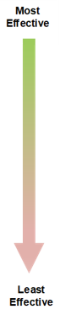
Eliminate
Before planning the Work at Height controls, structures and/or equipment, consider whether all, or any, of the Work at Height tasks can be done from the ground away from a risk of falling.

Isolate (Passive Fall Prevention)
If it is not possible to eliminate Work at Height, passive fall prevention devices are the preferred option, as after installation by a trained person, they do not require any action by any person to be protected (except regular inspection/ maintenance by the installer).

Minimisation through use of Harness Systems
The hierarchy for implementation of harness systems for Work at
Height is based on the maximum potential fall distance, through a
combination of anchorage placement and lanyard length:
- Total Restraint System (i.e., Fall Prevention)
- Work Positioning System (i.e., Limited Free Fall, <600mm)
- Fall Arrest System (i.e., Free fall of between 600mm and 2m)

This standard is written with reference to:
- MBIE Best Practice Guidelines for Working at Height in New Zealand
- WorkSafe NZ Best Practice Guidelines for Industrial Rope Access in New Zealand
- WorkSafe NZ Best Practice Guidelines for Mobile Elevated Work Platforms
- WorkSafe NZ Best Practice Guideline for Scaffolding in New Zealand

Workplace Inspection

Yes | No | N/A
 |  |  | Lighting
 |  |  | Ensure there sufficient lighting for performance of office tasks, >400 lux required for general office duties
 |  |  | Assure employees can control incoming natural light or glare sources as well as reflections from work surfaces or shadows
 |  |  | Noise/ Ventilation
 |  |  | Ensure that noise levels are not disturbing or disrupting the office workers; the recommended max office noise levels are 65 dB(a)
 |  |  | Ensure that office workers are in a well-ventilated area which isn’t too dry or too moist (a rule of thumb is there is insufficient ventilation if the room feels stuffy and over ventilated if people are experiencing dry eyes)
 |  |  | The office must have good temperature control and with a variation of 21-23ºC with minimal fluctuation (significant fluctuation causes undue fatigue)
 |  |  | Ensure there is adequate ventilation for photocopiers (300mm around the perimeter of the machine)
 |  |  | Office Layout
 |  |  | Ensure there is sufficient space for tasks to be carried out (width of walkways >90cm)
 |  |  | Ensure there is sufficient space for the equipment being used
 |  |  | All walkways to be kept clear
 |  |  | Conduct a blind spot inspection and install mirrors to assist with blind corners; high pedestrian traffic areas
 |  |  | Amenities
 |  |  | Ensure the building has a clean area for employees to eat which has sufficient seating arrangements for number of employees
 |  |  | The building should have sufficient toilets for the number of employees (approximately one toilet per gender per 50 people), and they should be maintained in a clean usable.
 |  |  | Workstations
 |  |  | Match the workstations to the task, so they are adequately designed for the task being performed
 |  |  | Conduct ergonomic assessments of the workstations to reduce awkward postures using the Spotless Workstation Ergonomic Assessment
 |  |  | Inspect the desks for suitability for the tasks being performed – eg. Reception work or packaging work versus regular office work.
 |  |  | Inspect chairs, ensure they are in good condition, stable and ergonomic with full adjustments in height and lumber support
 |  |  | Ensure sufficient storage space is provided for both the office and workstations. Any items >5 kg or big and bulky must be stored between shoulder and mid-thigh height.
 |  |  | Housekeeping
Implement housekeeping rules so floors of all offices, passageways, corridors, storerooms fire extinguishers and emergency exits are:
- Kept free from obstruction
- Properly maintained
- Covered with non-slip material
- Adequately illuminated
 |  |  | If required designate an area for the storage of faulty or disused equipment with rules on how long the equipment is to be stored in this area
 |  |  | Conduct inspection to identify sharp corners of furniture and other fittings and control these accordingly
 |  |  | Electrical Connections
 |  |  | Do not use power boards or extension cords, sufficient general power outlets must be installed at the workstations and other areas where power is required e.g. Photocopiers and printers
 |  |  | Implement a test and tag regime for all electrical cords and equipment including mobile phone chargers and laptop power cords, rule of thumb for office equipment test and tag frequency is six to 12 months
 |  |  | The office building must have an inbuilt Residual Current Device (RCD) system within the electrical circuit, if not, portable RCD’s must be used on all power points
 |  |  | Ensure all appliances are in good electrical condition i.e. no split or damaged cords or cracked machine cases exposing the internals of the machine.
 |  |  | First Aid Facilities
 |  |  | Allocate enough trained first aid officers, rule of thumb for offices is one per 30 people
 |  |  | Source a basic office first aid kit, recommended for any office first aid and emergency response scenario
 |  |  | Install a defibrillator, situated in an easily accessible area. The allocated first aiders must be trained in the use of the unit.
 |  |  | Initiate an inspection and regular replenishment of first aid kit contents against the recommended contents
 |  |  | Emergency Response
 |  |  | If not already in place, develop and implement an emergency response plan (ERP) with relevant scenarios
 |  |  | Make all personnel aware of the ERP
 |  |  | Ensure the building has a map available detailing the office floorplan that is linked to the ERP
 |  |  | Display the instructions for the ERP in the office for all personnel to view
 |  |  | Conduct evacuation drills if in the building, at a recommended frequency of six months but no longer than once per year
 |  |  | Incident and Hazard Reporting
 |  |  | Ensure that all employees are aware of how to report an incident / injury and hazard
 |  |  | Stairs
 |  |  | Inspect all staircases, these must be provided with a substantial handrail or handhold and anti-slip steps that comply with AS1657
 |  |  | Implement stair use rules like compulsory usage of handrails and prohibit the use of mobile phones and talking on stairways rule

Corrective Actions | Assigned to whom? | Completion Date

Inspection completed by (Full Name) | Signature | Date

Workstation Ergonomic Assessment

This checklist is designed to assist you in assessing your workstation and make some simple adjustments and improvements to optimise your comfort at work. If required, ask your Supervisor or Manager to assist.
This checklist should be used:
• When commencing employment as part of your induction.
• On relocation to another office/workstation (temporarily or permanently); and/or
• If you feel uncomfortable or experience pain or discomfort when sitting or standing at your workstation

If you suffer any discomfort or sustain an injury, please report to your Manager immediately.
Name
Date of Assessment

Section 1 – office chair |  | Is the risk controlled? |  |  |  | Comments/ further action
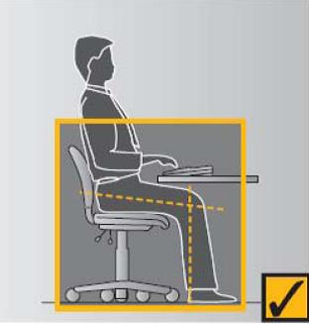 | Set the seat height so that:  - thighs are approximately horizontal and feet rest comfortably on the floor  - work surface/ keyboard is slightly below elbow height when shoulders are relaxed, and elbows are at approximately right angles  If the desk cannot be lowered, raise the height of the chair to achieve the correct posture and use a footrest to raise the height of the floor. | Yes | ☐ | No | ☐
 | Adjust the backrest so that its curve fits into the curve of the lower back, and it is centred at about waist level. | Yes | ☐ | No | ☐
 | Slightly tilt the backrest backward to reduce weight on the lower back. | Yes | ☐ | No | ☐
Section 2 – desk |  | Is the risk controlled? |  |  |  | Comments/ further action
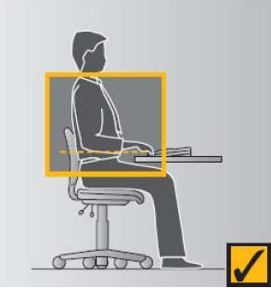  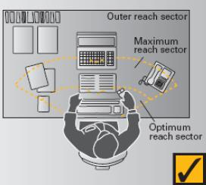  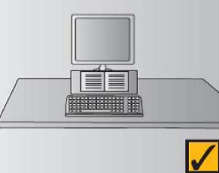 | Ensure there is adequate clearance underneath the desk to accommodate the chair and your legs.  Consult with your Manager about footrests, desk modification or replacement if your desk is too high/ too low. All modifications must be stable and secure. | Yes | ☐ | No | ☐
 | Remove any objects stored under the desk, such as rubbish bins, storage boxes and under desk filing cabinets, that may cause an obstruction. | Yes | ☐ | No | ☐
 | Ensure equipment is arranged so that it is within easy reach. Most frequently used items should be placed closer than less frequently used items. There should be room on the desk to move the keyboard away and create room for other tasks. | Yes | ☐ | No | ☐
 | If regularly using reference material, ensure there is enough space to place the material between the keyboard and the screen. A document holder can be used to hold the material if required. | Yes | ☐ | No | ☐
 | If you have an adjustable desk:  Raise/ lower the height of the desk to slightly below elbow height when elbows are bent to approximately 90 degrees.  If your desk has a keyboard tray that results in a difference in height between keyboard and mouse, raise the keyboard tray to allow minimise the gap between equipment if possible. | Yes | ☐ | No | ☐
Section 3 – Screen |  | Is the risk controlled? |  |  |  | Comments/ further action
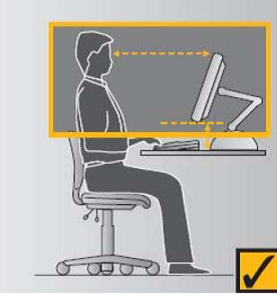 | Position the top of the monitor so that it is level with your eyes. Screen height can be adjusted using the mechanism on the monitor, using a monitor stand or using an object such as a telephone book. | Yes | ☐ | No | ☐
 | Where a laptop is used as the primary screen, use a separate keyboard so the laptop screen can be raised.  Laptops should be docked to a desktop whenever possible | Yes | ☐ | No | ☐
 | Place the screen approximately arm’s length away from your seated position or to a distance where you do not need to squint or peer forward or where you do not experience eye discomfort. | Yes | ☐ | No | ☐
 | Ensure the characters on the computer display are set at an appropriate size and colour and that the brightness and contrast are set for easy reading. | Yes | ☐ | No | ☐
Section 4 – keyboard |  | Is the risk controlled? |  |  |  | Comments/ further action
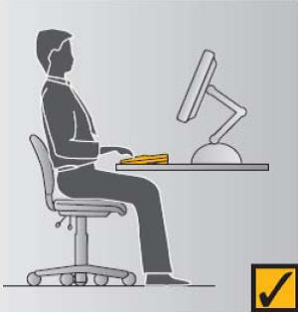 | Align the keyboard with the computer screen and placed directly in front of you near the front edge of the desk. | Yes | ☐ | No | ☐
 | Lower the feet at the rear of the keyboard to reduce its height and angle. | Yes | ☐ | No | ☐
Section 5 – mouse |  | Is the risk controlled? |  |  |  | Comments/ further action
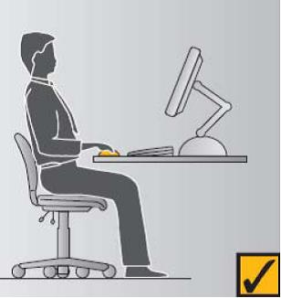 | Place the mouse close to your body to minimise reach. | Yes | ☐ | No | ☐
 | Ensure the desk supports the arm and the wrist is in a neutral position. | Yes | ☐ | No | ☐
 | Ensure the fingers do not hover over the buttons while using the mouse. | Yes | ☐ | No | ☐
 | Where a laptop is in use, a separate mouse should be used. | Yes | ☐ | No | ☐
Section 6 – environment |  | Is the risk controlled? |  |  |  | Comments/ further action
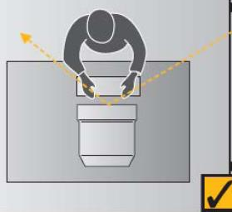 | Position the workstation to reduce glare and reflections on the screen. | Yes | ☐ | No | ☐
 | Create a comfortable working environment with good lighting, minimal noise, comfortable temperature and airflow. | Yes | ☐ | No | ☐

ADDITIONAL COMMENTS/ACTION PLAN/EQUIPMENT REQUIRED
MANAGER ACKNOWLEDGEMENT AND CORRECTIVE ACTIONS
Manager’s Name
Manager’s Signature |  | Date
Worker Signature |  | Date

Your Emergency Response Plan Guide

Your emergency response plan needs to include a site plan. Make sure the plan is accurate and drawn to scale so that anyone who needs to use it can identify the distances involved and any other relevant information about the location.
The plan could show, depending on the nature of your operation, the following items:
- a north point
- all hazardous substance locations and tanks or processing equipment for hazardous substances
- all buildings, entry and exit points to buildings, and any stairs or lifts
- the location of the fire alarm panel on your building
- the main electrical switchboard
- the main structures, roads, and landmarks on your site
- access points for emergency vehicles and any barriers or height limitations for vehicles entering the site
- the location of the nearest water supply, such as tanks or hydrants
  - if you have water tanks on site, the size of the tanks
  - if the nearest hydrant is not visible on the plan, place an arrow on the plan (where the plan shows the
- road outside your site) to indicate its direction
- the emergency evacuation meeting points
- access and shut-off points for gas, water, and electricity mains
- any major electrical transformers, generators, or other potentially hazardous plant
- shut-off valves for any piped gas or chemical processing systems
- any specialised fire safety systems, such as mist or drencher systems
- the location or direction of any high-risk neighbours such as:
  - schools or public meeting places
  - retirement homes or hospitals
  - petrol stations or neighbours that store large volumes of chemicals.
- Other useful information to include on your site plan:
- drains, marking the direction of flow, and any storm water grates on your site or on the road outside it
- the location of spill kits, first aid kits, fire extinguishers and any other emergency equipment
- the location of your SDS, inventory, and of the site plan.
- Use the space on this page for your site plan or to attach a copy of your site plan.

