Hazard Register
Version #, Date and Review Date

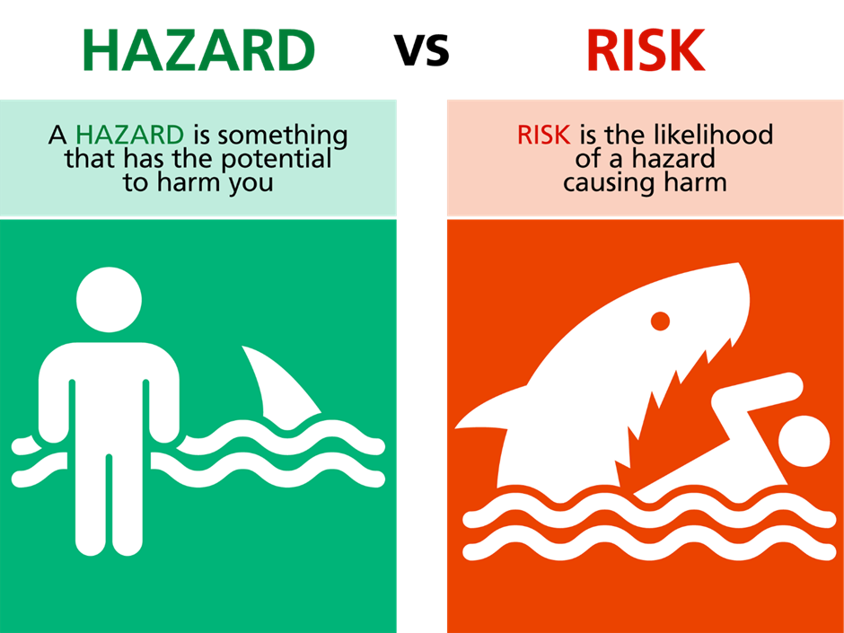

Hazard/ Risk | Initial Risk | Control(s) | Residual Risk

Insert Risk Matrix
