Health and Safety Manual

  - Version:
  - Date:
  - Review Date:

Contents
Health and Safety Manual 3
Health and Safety Management 7
Worker Engagement and Communication 8
Hazard Identification 8
Risk Management 9
Information, Training and Supervision 10
Monitoring and Review 11
Hazardous Substances 11
Events (injury/illness/incident/near miss) 11
Event Reporting and Recording 12
Event Investigation 12
Injury Management 13
Emergency Procedures and First Aid 13
Notification of Hazardous Work 14
Safe Plant and Equipment 14
Personal Protective Equipment (PPE) 14
Health Monitoring 15
Isolate or Lone Workers 15
Potentially Harmful Work Environments 16
High Risk Work 17
Isolation of Supply – Lock Out/ Tag Out 18
Prequalification and Management of Contract Workers 18
Job Health and Safety Management 18
Site Specific Safety Plans 19
Work Preparation and Job Induction 19
Client and Visitor Induction 19
Hazard Identification and Risk Management 19
Toolbox Meetings 20
Definitions 20

Health and Safety Manual

Our Health and Safety Manual will assist us in addressing our responsibilities under the Health and Safety at Work Act 2015 and Health and Safety at Work (General Risk and Workplace Management) Regulations 2016.

The following is a summary of the main legal obligations contained in the Health and Safety at Work Act 2015 and Health and Safety at Work Regulations 2015. Definitions of relevant terms contained in the Act and Regulations are also included:

PCBU DUTIES UNDER THE ACT

Every Person Conducting a Business or Undertaking (PCBU) must comply with health and safety legislation.

Ensure the safety of workers and others

As a PCBU you are required to ensure the safety of workers and others, so far as reasonably practicable. This includes workers who are employed or engaged by you, workers who are directed or influenced by you and any other person who enters your place of work or who is put at risk by your work.

To address your duties as a PCBU you must ensure you provide and maintain (as far as reasonably practicable):
- A work environment without risks to health and safety.
- Safe plant and structures.
- Safe systems of work.
- The safe use, handling, and storage of substances.
- Adequate facilities for the welfare at work of workers.
- Any information, training, instruction, or supervision that is necessary to protect all persons from risks relating to the work they are doing.
- Monitoring the health of your workers and the conditions at the workplace to prevent illness or injury; and
- You must also maintain any premises so that a worker occupying the premises is not exposed to risk.

Duty to provide training and supervision

PCBUs are also required to provide worker training and supervision. Workers must be competent to do their work, made aware of the potential hazards and expected risk controls. There must be a system for dealing with any emergencies that occur at work.

Duty to notify events

PCBUs must notify WorkSafe NZ of any Notifiable Events, which include a death, notifiable incidents and notifiable injury or illness.

Duty to engage workers

PCBUs are required to engage with workers on health and safety matters.

Right of workers to refuse work

Workers have the right to refuse to do work that could cause them harm.

Health and Safety obligations

PCBUs cannot contract out of health and safety obligations.
Duty to ensure workplace is safe

A PCBU with management or control of a workplace must also ensure that the workplace, the means of entering and exiting the workplace, and anything arising from the workplace are without risks to the health and safety of any person.

Duty to consult with other duty holders

PCBUs who have a duty relating to the same matter (e.g., working on the same job) must, so far as is reasonably practicable, consult, co-operate with, and co-ordinate activities with all other PCBUs who have a duty in relation to the same matter.

PCBU DUTIES UNDER THE REGULATIONS

Identify hazards

PCBUs have a duty to identify foreseeable hazards that could give rise to risks to health and safety.

Review risk controls

PCBUs who implement risk controls must ensure they are effective, maintained and remain effective, including ensuring they are:
- Fit for purpose.
- Suitable for the nature and duration of the work; and
- Installed, set up and used correctly.

Duty to maintain controls

PCBUs must review and revise risk control measures to maintain a work environment that is free of risks to health and safety. Reviewing risk controls is required:
- When the control does not control the risk (e.g., after a review or accident).
- Before a change at the workplace that could create a new risk (e.g. use of new equipment or change of job step).
- A new hazard or risk is identified (by a worker or other person); and
- As a result of a health monitoring report.

Provide training and supervision

PCBUs must ensure that every worker conducting work, using plant or handling substances:
- Has the knowledge and experience to ensure the work they are doing does not cause harm to the worker or others.
- or Is supervised by a person who has the knowledge and experience; and
- Is adequately trained in the safe use of plant, objects, substances, and equipment that the worker is required to be used; and
- Has all protective clothing that the worker is or may be required to wear.

Manage airborne contaminants

PCBUs with management or control of a workplace must ensure that facilities are provided:
- To control airborne contaminants as closely as possible to their source; and
- For the treatment of or carrying off airborne contaminants to minimize the chance of harm to workers.

Provide first aid

PCBUs must ensure:
- That adequate first aid equipment is provided for the workplace and is accessible to all workers; and
- An adequate number of workers are trained to administer first aid; or
- Workers have access to an adequate number of persons who have been trained to administer first aid.

Provide an Emergency Plan

PCBUs at a workplace must ensure that an emergency plan is prepared for the workplace.
The Emergency plan must provide emergency procedures that:
- Provide an effective response to an emergency.
- Detail how to evacuate.
- Detail how to notify emergency services and others at the earliest opportunity.
- Identify medical treatment and assistance to be provided.
- Provide effective communication to coordinate the emergency response.
- Provide for regular testing of the emergency plan; and
- Provide effective communication, training, and information to workers to implement the emergency plan.

Provide PPE

PCBUs who direct the carrying out of work must provide PPE to workers unless the PPE has been provided by another PCBU.

PCBUs must ensure that the PPE selected is:
- Suitable for the nature of the work and the hazards associated with the work.
- A suitable size and fit and reasonably comfortable for the worker who uses it.
- Clean and hygienic; and
- In good working order.
- PCBUs must also ensure:
- PPE is used or worn by the worker.
- PPE is compatible with any other PPE being used or worn by the worker; and
- That workers are trained in the use and maintenance of PPE.

Manage remote or isolated workers

PCBUs must manage risks to health and safety of workers associated with remote or isolated work.
When minimising this risk, a PCBU must provide a system of work that includes effective communication with a worker.

Manage hazardous atmospheres

PCBUs with management or control of a workplace must manage risks to health and safety associated with a hazardous atmosphere at a workplace.

Manage ignition sources

PCBUs with management or control of a workplace must manage risks to health and safety associated with an ignition source in a hazardous atmosphere at a workplace.

Manage falling objects

PCBUs with management or control of a workplace must manage risks to health and safety associated with any falling object likely to injure a person at a workplace.

Manage hazardous containers

PCBUs with management or control of a workplace must ensure that where there is a hazardous container at the workplace:
- It is securely covered; or
- Enclosed by a secure fence that extends 1 metre above the floor, ground, or platform.

Duty to provide health monitoring

PCBUs must ensure that health monitoring is provided to any worker who may be exposed to a substance hazardous to their health relating to:
- An identifiable disease or health effect.
- The likelihood a disease or health affect will occur under the conditions of work; and
- The use of valid techniques to detect a disease or health effect.

PCBUs are required to inform workers of all relevant information regarding the health monitoring including how the monitoring is to be conducted and the results of any monitoring.

Officer Duties

Officers of a PCBU must:
- Acquire and keep up to date knowledge of work health and safety matters.
- Gain an understanding of the nature of your operations and the hazards and risks associated with those operations.
- Ensure that when work is carried out, appropriate resources and processes are available for use (and are used) to eliminate or minimise risks to health and safety.
- Ensure appropriate processes are in place for receiving, considering, and responding in a timely manner to information regarding incidents, hazards, and risks.
- Ensure that processes are implemented for complying with any duty or obligation of a PCBU under the Act; and
- Verify (regularly check) that processes and resources have been provided and used.

Worker Duties

Workers engaged or employed by a PCBU must:
- Take reasonable care for their own health and safety.
- Take reasonable care they do not adversely affect the health and safety of other persons.
- Comply with any reasonable instruction that is given by a PCBU; and
- Cooperate with any reasonable policy or procedure of a PCBU relating to health or safety in the workplace.

When using PPE, workers must:
- Use and wear PPE in accordance with reasonable instructions of the PCBU.
- Not intentionally damage or misuse PPE; and
- Report any unfit, damaged, or defective PPE to the PCBU.

Duty to Manage Risk

As a person under the Act, you have a duty to:
- Eliminate risks to health and safety, so far as reasonably practicable, or if not reasonably practicable; to Minimise those risks so far as is reasonably practicable.

This duty applies to PCBUs, workers and other persons with a duty under the Act. In other words, risk management is everyone’s responsibility.

The most important part of this process involves the creation and use of a system that identifies hazards and manages risks.

The management of risks requires the controlling of the risk through:
- Elimination of the risk of any hazard causing death, injury, or illness; and
- If elimination is not possible by minimising the risk of the hazard causing death injury or illness.

Minimisation controls include:
- Substituting (wholly or partly) the hazard creating the risk with something that lowers the risk.
- Isolating the hazard from any person who could be exposed to it; and/or
- Implementing engineering controls.

- If the risk remains, you must further minimise the risk by using administrative controls such as: work methods.
- procedures; checklists; and PPE.

If you must minimise the risk, then where possible multiple risk controls should be used.

Health and Safety Management

Our health and safety system contains a set of Health and Safety Objectives.

These objectives help us manage our health and safety duties, ensure we implement our health and safety system effectively and demonstrate continuous improvement in occupational health and safety.

We will use these objectives as a guide to implement our health and safety procedures and each objective will be put in place progressively.

Worker Engagement and Communication

We will establish appropriate communication and participation methods with all workers in our workplace, to ensure all information regarding safety is discussed and passed on.

As a PCBU we will engage our workers to help us:
- Identify hazards and assess risks;
- Make decisions about ways to eliminate or minimise risks;
- Make decisions about the adequacy of our health and safety facilities; and decide on appropriate worker participation practices.

This will involve:
- Sharing information on health and safety with our workers;
- Allowing our workers to express their views, raise work health and safety issues and contribute to the decision-making process;

Considering the views of workers;
- Advising workers of the outcome of any discussions and decisions; and
- Involving any Health and Safety Representative in our discussions.

We will do this by:
- Inducting all workers to our workplace;
- Ensuring all workers have attended inductions for our clients as required;
- Providing sufficient information and training specific to the health and safety risks for the work being undertaken.
- Ensuring workers have an opportunity to participate in health and safety via health and safety meetings and (where applicable) health and safety representatives.
- Holding quarterly Health and Safety Meetings with management and workers.
- Agreeing (as a group) on any required actions and documenting these in our Health and Safety Meeting Minutes;
- Making the Health and Safety meeting outcomes available to all workers; and
- Holding monthly toolbox meetings where workers can raise any issues, they feel necessary.

Hazard Identification

All Hazard identified will be recorded in our Hazard Register. The Hazard Register is a record of all significant hazards that have not been eliminated and may be present in our workplace. The Register will be regularly reviewed to ensure it remains up to date.

Our Hazard Register will be held in the workplace and used as a reference document. There might be the need for a site-specific Hazard Register if work is being carried out away from our normal work premises.

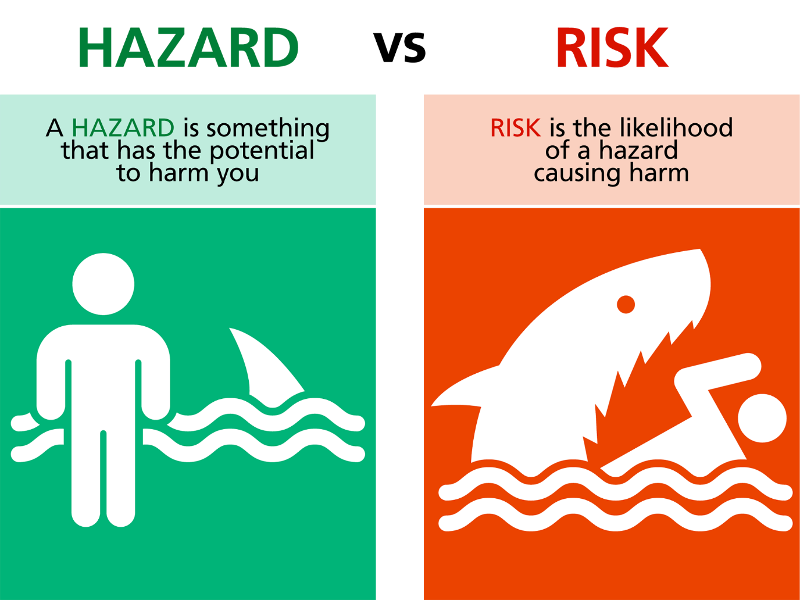

Risk Management

Once hazards have been identified they will be assessed and controlled by eliminating or minimising any risks to health and safety.

Eliminate: Where reasonably practicable, we will remove the chance of a hazard causing death, injury or illness.

Minimise: Where we cannot eliminate the risk, we will as far as reasonably practicable reduce the chance of the hazard causing death, injury or illness by one or more of the following:

- Substitute (wholly or partly) the hazard creating the risk with something that creates a lesser risk;
- Isolate the hazard from any person who could be exposed to it; and/or
- Implement engineering controls.

If the risk remains, we will further minimise the risk by using:
- Administrative controls (such as safety procedures and checklists etc); and
- Personal Protective Equipment (PPE).

Work related hazards and the risk controls are listed in the following resources:
- Hazard Register
- Safe Work Method Statement and
- Written on Workplace Hazard Board(s).

Hazards that relate to visitors entering the workplace and the actions to control risks to health and safety are written on our Hazard Board and will be displayed at the entrance(s) to the job site where required.

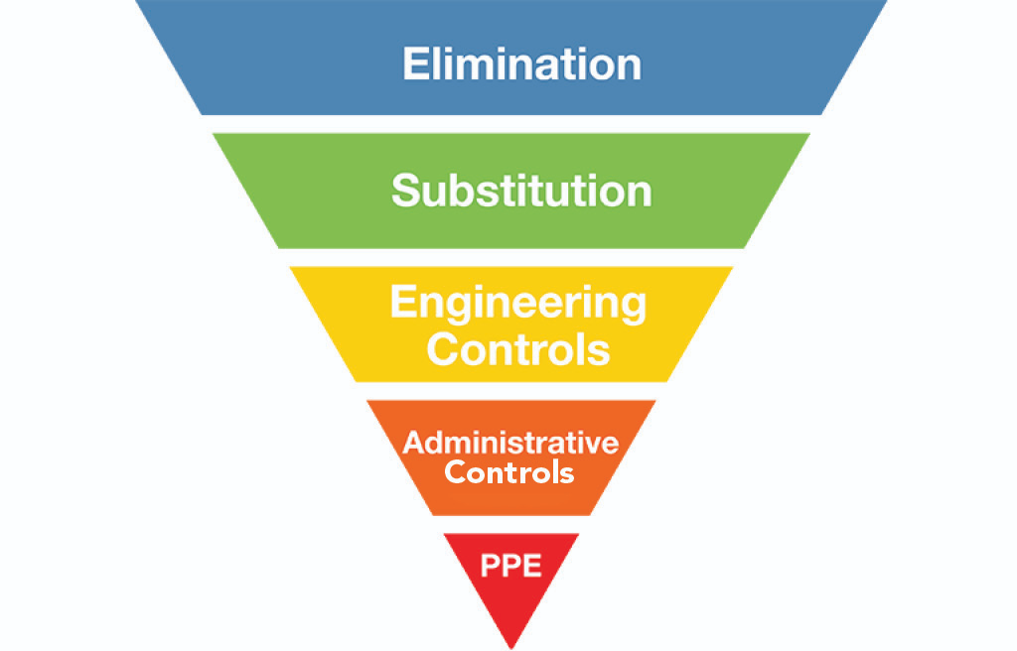

Information, Training and Supervision

We will ensure all workers are sufficiently competent and/or trained to do their work safely or are supervised by a competent person. An Initial assessment of each worker will be carried out at the stage of induction and recorded in the Training and Competency Register.

The Training and Competency Register will also be used as a tool to identify any potential training needs of our workers. Where training needs are identified those will be discussed at the Toolbox meeting and scheduled accordingly.

Any worker not competent to work alone or conduct certain task by themselves will be provided with the appropriate supervision.

We will ensure that all contractors are sufficiently competent and hold all the relevant qualifications for the work they are engaged to carry out. An assessment will be done via the Contractor Approval Form.

Workers will also be trained in the safe use of plant and equipment, including the use and maintenance of Personal Protective Equipment (PPE). Competency will be assessed via the Competency Check and updated on the Training Register.

Monitoring and Review

We will ensure all workers are meeting the required standards of health and safety by conducting regular Office Inspections or Site Inspections and others as required.

Inspection findings will be discussed with all workers at our regular Toolbox Meetings held at the workplace.

Completed Job-Start Forms, Vehicle Checklists etc. will be submitted to the PCBU. The requirement will be communicated to the worker during the workplace induction.

Hazardous Substances

Hazardous substances are substances that are explosive, flammable, oxidising, toxic, corrosive, or toxic to the environment (ecotoxic).

The HSNO classes are:
- Class 1 – explosives
- Class 2 – flammable gases
- Class 3 – flammable liquids
- Class 4 – flammable solids
- Class 5 – oxidising substances
- Class 6 – substances toxic to people
- Class 8 – corrosive substances
- Class 9 – substances toxic to the environment.

To keep our workers safe, we will put the following controls in place for hazardous substances in any quantity:
- We will keep an inventory of all Hazardous Substances used, handled, manufactured, and stored by our PCBU and our workers
- We will make the up-to-date Safety Data Sheets for all products available in our workplace and to our workers; that includes having them in vehicles where required
- We will share the relevant information, instructions and training to our workers and record their training and or competency in our training register. Where required supervision will be provided
- We will have the relevant emergency response plan in place
- We will ensure all containers are labelled as required, including hazardous waste
- We will provide our workers with additional PPE where required for safe handling of hazardous substances

Events (injury/illness/incident/near miss)

In the event of an accident where a person appears to be injured, our priority is to preserve life by providing first aid and calling the emergency services on 111.

Emergency Response Plans are available, and workers will be shown where those are available as well as the locations of First Aid Kits as part of their Induction to the workplace.

We will always aim to have a person qualified in first aid in our workplaces. Sufficient First Aid Kits will be available in the workplace and checked as part of the office check.

A First Aid Kit will be provided for each vehicle and the contents checked as part of the monthly vehicle check.

We will ensure that if there is a notifiable injury or event, our workers will preserve the accident site by leaving everything as it is until we have permission from WorkSafe NZ to clean up or
move anything. We will also take photos of the accident site as a record of what has happened.

All accidents and near miss incidents will be recorded and investigated using the Event Report Form and updated in the Incident Register.

Event Reporting and Recording

The Event Report Form for recording and reporting any incident or injury will be available in the workplace and on site. Workers are expected to report all injuries and near-miss incidents to the relevant parties as soon as reasonably practicable. The requirement will be discussed as part of the induction and at toolbox meetings if required.

Minor injuries and near miss incidents will be recorded on the Event Register by the director or worker in control of the workplace and discussed at the next Toolbox Meeting.

All notifiable events will be immediately reported to WorkSafe NZ via the online form on the WorkSafe website.

If the incident has happened on our client’s site, we will inform our client and make an incident investigation report available as early as possible.

All event documentation will be kept for a minimum of 5 years.

Event Investigation

We will investigate all accidents, incidents and near misses (events) to determine whether they were caused by hazards or risks to health and safety.

Where applicable, we will also find out what risk controls were absent and should be put in place to manage any hazard and prevent a repeat of the same occurrence.

Where required we will report back to WorkSafe NZ on the prescribed form, any system changes we have made because of an event.

All persons present at the time of the event are expected to assist in any investigation.

The worker in control of the workplace is responsible for investigating events and documenting their findings using the Event Form.

Event investigation findings will be discussed at our Toolbox Meetings and Health and Safety Meetings and a remedial action plan will be put in place, recorded in the Health and Safety Meeting Checklist, and reviewed at subsequent meetings.

Injury Management

Where harm has occurred, a managed return to work is our preferred choice depending on the degree of injury and the availability of suitable tasks that will not exacerbate the injury. We believe this outcome to be both desirable and beneficial to all parties involved.

If a Worker sustains an injury that a medical professional believes will not preclude the Worker from some form of work, our policy is (where possible) to provide useful alternative duties to ensure a continued connection with the workplace and a managed recovery. Consult with the Worker, ACC, and appropriate medical professionals to action the programme.

If an injured Worker cannot return to alternative duties, the Company will remain in contact with the Worker to monitor their progress and ability to return to work.

If a Worker has sustained a long-term injury and is not able to return to the duties they were originally employed to do, the Company will, if possible, provide alternative work that the injured Worker can do. All parties involved should be aware that this may not be feasible and that termination of employment, while never desirable, may be necessary. In this situation, the Company will do whatever it reasonably can to ease the transition.

Emergency Procedures and First Aid

We will provide a completed Emergency Plan for our workplace(s) and ensure it is available for our workers (and contractors) wherever they are doing work.

Where work is being carried out at our own premises, we will make sure the Emergency Plan is discussed as part of the Induction and location of First Aid facilities and another Emergency Equipment is discussed as well.

We will also ensure that adequate number of workers are trained as first aiders. Those qualifications are part of the Training Register and we will ensure to assess the need for additional workers requiring training on a regular basis.

Where we are required to complete a SSSP or similar for work carried out at our clients premises we will attach the Emergency Plan to the Site-Specific Safety Plan.

The supervisor or person in control of the workplace is responsible for ensuring that the Emergency Plan is kept up to date and that all workers (including contract workers) have read this and are familiar with its content.

Notification of Hazardous Work

The requirement to notify WorkSafe NZ is defined in the Health & Safety Regulations (Health and Safety in Employment Regulations 1995).

Where hazardous work is to be carried out by our company, WorkSafe NZ will be informed via the online form at least 24 hours prior to commencement of such work. Notification is completed online, via WorkSafe NZ’s website at: https://worksafe.govt.nz/notifications/hazardous-work/

An electronic confirmation will be received, and a copy of this notification will be kept for our records. A copy of this confirmation will also be added to our Site-Specific Safety Plan (when applicable).

A copy of any completed Notification of Hazardous Work Forms will be held in the workplace for the duration of the job.

If engaged in hazardous work, all workers involved will be competent to perform the work and, where applicable, will be holders of an appropriate qualification. Those records will be kept and updated accordingly in the Training Register.

Safe Plant and Equipment

We will ensure that all plant and equipment supplied to and used by workers is of the required standard and is in good working order with all safety mechanisms and guards intact.

All plant and equipment will have a Standard Operating Procedure (SOP) or manufacturers’ instructions containing information on its safe operation and maintenance.

If any plant or equipment is not in safe working order, it will be removed from service and repaired by a competent person before any further use. All plant and equipment will be recorded in the Plant and Equipment Register.

Workers will be made aware of their obligation (during induction) to regularly inspect plant and equipment and to immediately stop work and report to their PCBU, if any damage or fault poses a risk of death, injury, or illness.

There will be a requirement for workers to complete regular checks on certain plant and equipment using the relevant checklist. For example, monthly vehicle and ladder checks. The worker will be told which ones need to be completed and at which frequency during their induction.

All workers must be trained and competent to use plant and equipment before allowed using it unsupervised. The initial assessment will be recorded in the Training Register at the time of induction and any training needs identified and scheduled accordingly. Where required we will ensure that workers are supervised when using plant and equipment

Personal Protective Equipment (PPE)

Where there is a need to further minimise a risk to health and safety, we will ensure our workers are provided with the necessary Personal Protective Equipment (PPE).

We will ensure the PPE provided to our workers is:
- Suitable, considering the nature of the work and any hazards relating to that work;
- A suitable size and fit and reasonably comfortable for our workers;
- Compatible with other PPE.
- Maintained, stored, and repaired so that it continues to be effective (e.g., clean, hygienic and in good working order).
- Used or worn by workers; and
- Provided along with information, training, supervision and instruction on the proper use, storage and maintenance of the PPE.

We will establish a minimum PPE requirement for our workplace, which will be monitored during workplace inspections or day to day observations.

Specific PPE requirements for machinery, tasks and the handling of substances are identified in Standard Operating Procedures (SOPs), manufacturers’ instructions, Safety Data Sheets (SDSs) and the Hazard Register.

Where applicable, PPE such as dust masks, hearing protection etc will be maintained to a schedule and recorded in the PPE Register and relevant training in the Training Register.

We will ensure that contract workers (other PCBUs), supply suitable PPE appropriate for the job they are undertaking and make sure it is used and maintained correctly.

Health Monitoring

Where there is the risk of a specific illness through exposure to hazards and these cannot be eliminated, we will minimise these risks by monitoring the health of our workers.

Illnesses would include noise induced hearing loss, respiratory issues from exposure to hazardous atmospheres or airborne contaminants and other long-term illnesses such as asbestosis and silica dust related cancers developed in the workplace.

Where applicable we would obtain a baseline of our workers’ health by conducting pre- employment health checks and by regular on-going monitoring of workers and the workplace. This may involve obtaining specialist health monitoring advice.

We will, so far as reasonably practicable, obtain our workers consent to the monitoring of their health in relation to these hazards. We will be proactive in seeking approval and take responsibility for informing and encouraging workers about health monitoring, where appropriate.

We acknowledge consent must be granted voluntarily and without any form of coercion or duress.

We will also inform workers of the results of any health and safety monitoring undertaken to meet the risk management requirements of the Act.

Isolate or Lone Workers

When workers are working alone, or in isolated areas, where they can’t physically see or talk to other workers, we ensure the following risk controls are in place.
- Have an Emergency Plan that includes a method of regular communication.
- Worker is to be first aid trained and have a first aid kit available.
- Worker is to be fully trained and competent in the task being completed (not an apprentice or inexperienced worker).
- Workers must be provided with the correct tools and PPE
- Lone or isolated workers must be regularly checked on.

Potentially Harmful Work Environments

Where there is a risk of illness or injury through exposure to hazards and these cannot be eliminated, we will minimise these risks by monitoring exposure levels and providing the appropriate PPE.

Noise

Where noise presents a hazard in the workplace, we will ensure work is carried out in accordance with the Approved Code of Practice for the Management of Noise in the Workplace.
Regardless of whether hearing protection is being worn, we will ensure that no worker is exposed to noise above the following levels:

Eight-hour equivalent continuous A-weighted sound pressure level of 85dB; and Peak sound pressure level of 140dB.

All staff will be issued with AS/NZ 1270:2002 Class 5 hearing protection for any work that exceeds noise levels of 85 decibels. Staff will get the option between ear muffs and ear plugs of a Class 5 level.

Where appropriate we will undergo health monitoring of workers exposed to continuous or peak noise levels.

Dust, Airborne Particles and Hazardous Atmospheres

Where exposure to dust, airborne particles or hazardous atmospheres presents a hazard in the workplace, we will ensure the workplace is monitored in accordance with Regulations and WorkSafe NZ’s fact sheet, which outlines the following steps to be taken:

- Hazards must be identified;
- Risk control methods are developed and used;
- Respiratory protection is provided;
- Air monitoring of the workplace is undertaken regularly;
- Workers are trained on the hazards associated with the work they are undertaking;
- Workers are trained on the correct use and maintenance of PPE provided; and
- Warning signs are put in place as required.

Where appropriate we will undergo health monitoring of workers exposed to dust, airborne particles or hazardous atmospheres.

Loose Materials

As required by workplace Regulations, where a worker could become entrapped or engulfed by materials e.g. excavations etc, we will provide a suitable and fit for purpose safety harness attached to a securely fastened lifeline.

We will also ensure a suitably trained and competent worker is stationed to immediately rescue any worker who becomes trapped or engulfed.

High Risk Work

As a PCBU we will ensure that all high-risk work is carried out in accordance with the relevant standards, codes of practice and guidelines.

Electrical Work

A qualified and registered electrician, with a current practicing license, must carry out all prescribed electrical work as outlined in AS/NZS 3000:2007 Electrical Installations. All electrical work carried out must have a certificate of compliance provided by the electrician upon completion.

Gas Installations

A qualified and registered gas fitter, with a current practicing license, must carry out all installation work as outlined in AS/NZS 5601:2013 Gas Installations. All installation work carried out must have a certificate of compliance provided by the gas fitter upon completion.

Working at Height

All work at height will be carried out in accordance with the best practice guidelines for Working at Height in New Zealand. All workers using harnesses at height will be trained in the safe use of a harness for fall protection when working at height Unit Standard (US) 23229 and all supervisors will be trained to US 15757.

If a Mobile Elevating Work Platform (MEWP) is required, then all work will be carried out in accordance with the best practice guidelines for mobile elevating work platforms. Any worker required to operate a MEWP will be trained to the relevant US for the type of MEWP as outlined in the guidelines.

Confined Spaces

All work carried out in a confined space as defined by AS/NZS 2865:2001 Safe Working in a Confined Space, must be carried out in accordance with the standard. All workers undertaking work in a confined space will be trained to US 17599 & US 18426.

Asbestos

All work involving the identification, removal, handling, disposal of asbestos containing material (ACM) or asbestos contaminated dust (ACD) will be conducted in accordance with Health and Safety at Work (Asbestos) Regulations 2016 and the Management and Removal of Asbestos Approved Code of Practice (ACOP).

Where our work creates a risk of asbestos contamination, asbestos has been identified or it is assumed asbestos is on site, we will ensure that we obtain and review an Asbestos Management Plan from the building owner or the person who has management or control of the site.

Where required to remove and dispose of asbestos a licensed asbestos removalist (Class A or B) will be used. If a licensed removalist is not required (up to and including 10m2 of non-friable ACM or ACD, cumulatively over the whole course of the removal project for the site), we will ensure the removal process is in accordance with the Asbestos Regulations and Management.

Isolation of Supply – Lock Out/ Tag Out

All work that effects or interferes with the supply or potential supply of gas, electricity or water shall be carried out under a Lock Out/Tag Out system.

This system shall consist of a physical lock being placed at the point of isolation with an identification tag with the name and number of the qualified person completing the isolation.
If more than one worker is reliant on this isolation, then he/she will place his/her own lock and identification tag at the isolation point. This is to ensure that no point of supply can be re-instated without the knowledge of all affected by the isolation.

Lock Out/Tag Out systems must not be removed or reinstated by any person other than the person who installed them.

All other mechanically generated sources of energy, such as pneumatic or hydraulic energy sources, should also be physically isolated (e.g. chocked or secured with a chain etc) when undergoing maintenance and/or servicing.

Prequalification and Management of Contract Workers

As a PCBU we will ensure all workers, including any contract workers, have and use the appropriate resources and processes to eliminate or minimise health and safety risks.

To do this we will pre-qualify new contract workers, to ensure they are competent in health and safety management via the Approval Form. No contractor can start any work without having gained formal approval form us.

If any of our work involves the engagement of or working alongside other PCBUs (e.g., sub-contractors working on the same job), we will consult and cooperate with all contractors involved and coordinate all activities to ensure risks are managed appropriately.

Job Health and Safety Management

To manage the overall safety for each job, prior to the start of any work, we will follow the procedures outlined in the Health and Safety Manual.

The worker in control of the workplace will be responsible for carrying out these procedures. And not to start any work without ensuring hazards have been identified and controlled.
Where required we will train our staff in the use of SOP, SDS, Hazard ID Form and SWMS etc.

Site Specific Safety Plans

Where required by our clients we will submit a Site-Specific Safety Plan (SSSP) prior to the start of the project.

Work Preparation and Job Induction

Prior to the start of any work, all workers are expected to ensure they carry out a Job-Start Form.

That step ensures workers are suitably prepared for the work they are about to do.
If more than one worker is present the supervisor or worker in control will induct all workers to the workplace.

Where applicable workers will also be taken through the SWMS or SSSP for the work being carried out. Once that is done workers need to sign onto the relevant document confirming their understand and agree with the process outline in the documents.

Where working with other workers on the same site there might be the requirement to discuss the hazards and controls in the Job-Start Form with other workers to ensure everyone is sufficiently aware of Hazards and relevant controls.

Where necessary the Hazard Board should be updated with new Hazards introduced to the workplace.

Client and Visitor Induction

When applicable, the Client will be informed of any hazards that they might encounter while we are doing work.

Visitors to the workplace should be met at the entrance to the workplace and taken through the Visitor Induction, then escorted for the duration of their visit.

Hazard Identification and Risk Management

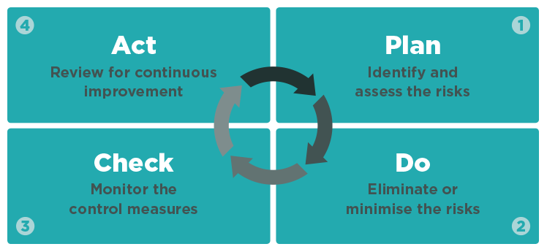

Toolbox Meetings

We will carry out monthly toolbox meetings which are mandatory to attend for all workers and will be recorded in the Toolbox Meeting Minutes.

Definitions

Reasonably Practicable: means what can reasonably be done to ensure health and safety considering:
- The likelihood of the hazard occurring;
- The degree of harm that might occur;
- What the person knows or should know about the hazard and how to manage it;
- The availability of ways to manage the hazard; and
- The costs versus the risk

Workplace: a place where work is carried out including where a worker goes while at work (includes vehicles, mobile structures, aircraft, ship etc).

PCBU: a person conducting a business or undertaking, whether alone or with others and regardless of for profit or gain – excludes those defined as workers.

Officer: a company, any person occupying the position of director, a partnership, any general partner, body
corporate, an unincorporated body and any person occupying a position in such an organisation. Any person who makes decisions in an organisation that affects the whole or substantial part of the business.

Worker: a person who carries out work in any capacity for a PCBU (includes employees, contractors,
subcontractors, employees of labour hire companies, apprentice or trainee, person gaining work experience and volunteers)

Risk: the possibility that death, injury or illness might occur when a person is exposed to a hazard.

Hazard: a situation or thing that has the potential to cause death, injury or illness (includes a person’s behaviour).

Health: means physical and mental health.

Risk Management: controlling a hazard through Elimination or Minimisation strategies or controls.

Visitors: includes groups such as customers, hospital patients, contractors or other visitors to a workplace, an employee’s family, passers-by and any other person who may be affected by the work activity.

Plant: any machinery, vehicle, equipment (including PPE), appliance, container, implement, or tool and any component or fitting connected to any of these things.

Notifiable Event: means the death of a person or a notifiable injury or incident (refer www.legislation.govt.nz for full definition).

Training: the provision of adequate (relevant to the nature of the work and its risks) and readily understandable information or instruction.

- Best practice guideline for working at height
- Best practice guideline for working on roofs
- Best practice guideline for scaffolding in NZ
- Industrial rope access in NZ
- Manual handling code of practice
- Mobile elevated work platforms
- Safe use of portable mechanically powered nailers and staplers
- Respiratory protection
- Safe use of safety nets
- Guide for safety with underground services

These documents and related fact sheets can be viewed on WorkSafe NZ’s web site at the following link: https://worksafe.govt.nz/

